**­A PROJECT REPORT ON**

**DEVELOPING WEBSITE FOR SIAMAQ PORTAL**

**DEVELOPED FOR**

**SIAMAQ CONSULTANCY PVT. LTD., PUNE**

**BY**

**MISS. PURVA DILIP WARKE.**

**SEAT NO: 367617**

**FOR THE PARTIAL FULFILLMENT OF THE DEGREE MASTER OF COMPUTER APPLICATION**

**SUBMITTED TO**



**KCES’s INSTITUTE OF MANAGEMENT AND RESEARCH, JALGAON**

**AFFILIATED TO**

**KAVAYITRI BAHINABAI CHAUDHARI NORTH MAHARASHTRA UNIVERSITY, JALGAON**

**2022-2023**

C e r t i f i c a t e

To whomsoever, it may concern

This is to certify that Miss. Purva Dilip Warke a student of Master of Computer Application from KCES’s Institute of Management and Research, Jalgaon has completed the full-time Industrial Training with a project titled “Developing Website for Siamaq Portal” at Siamaq Consultancy Pvt. Ltd., Pune.

She has submitted a satisfactory report in partial fulfillment of the requirement for the award of the degree of Master of Computer Application during the academic year 2022-2023.

( Miss. Ankita Tiwari )

Internal Guide

(Mr. Uday Chatur)

Coordinator

(Dr. Tanuja Fegade)

HOD, Academic Dean

(Prof. Dr. Shilpa Bendale)

Director

External Examiner

External Examiner

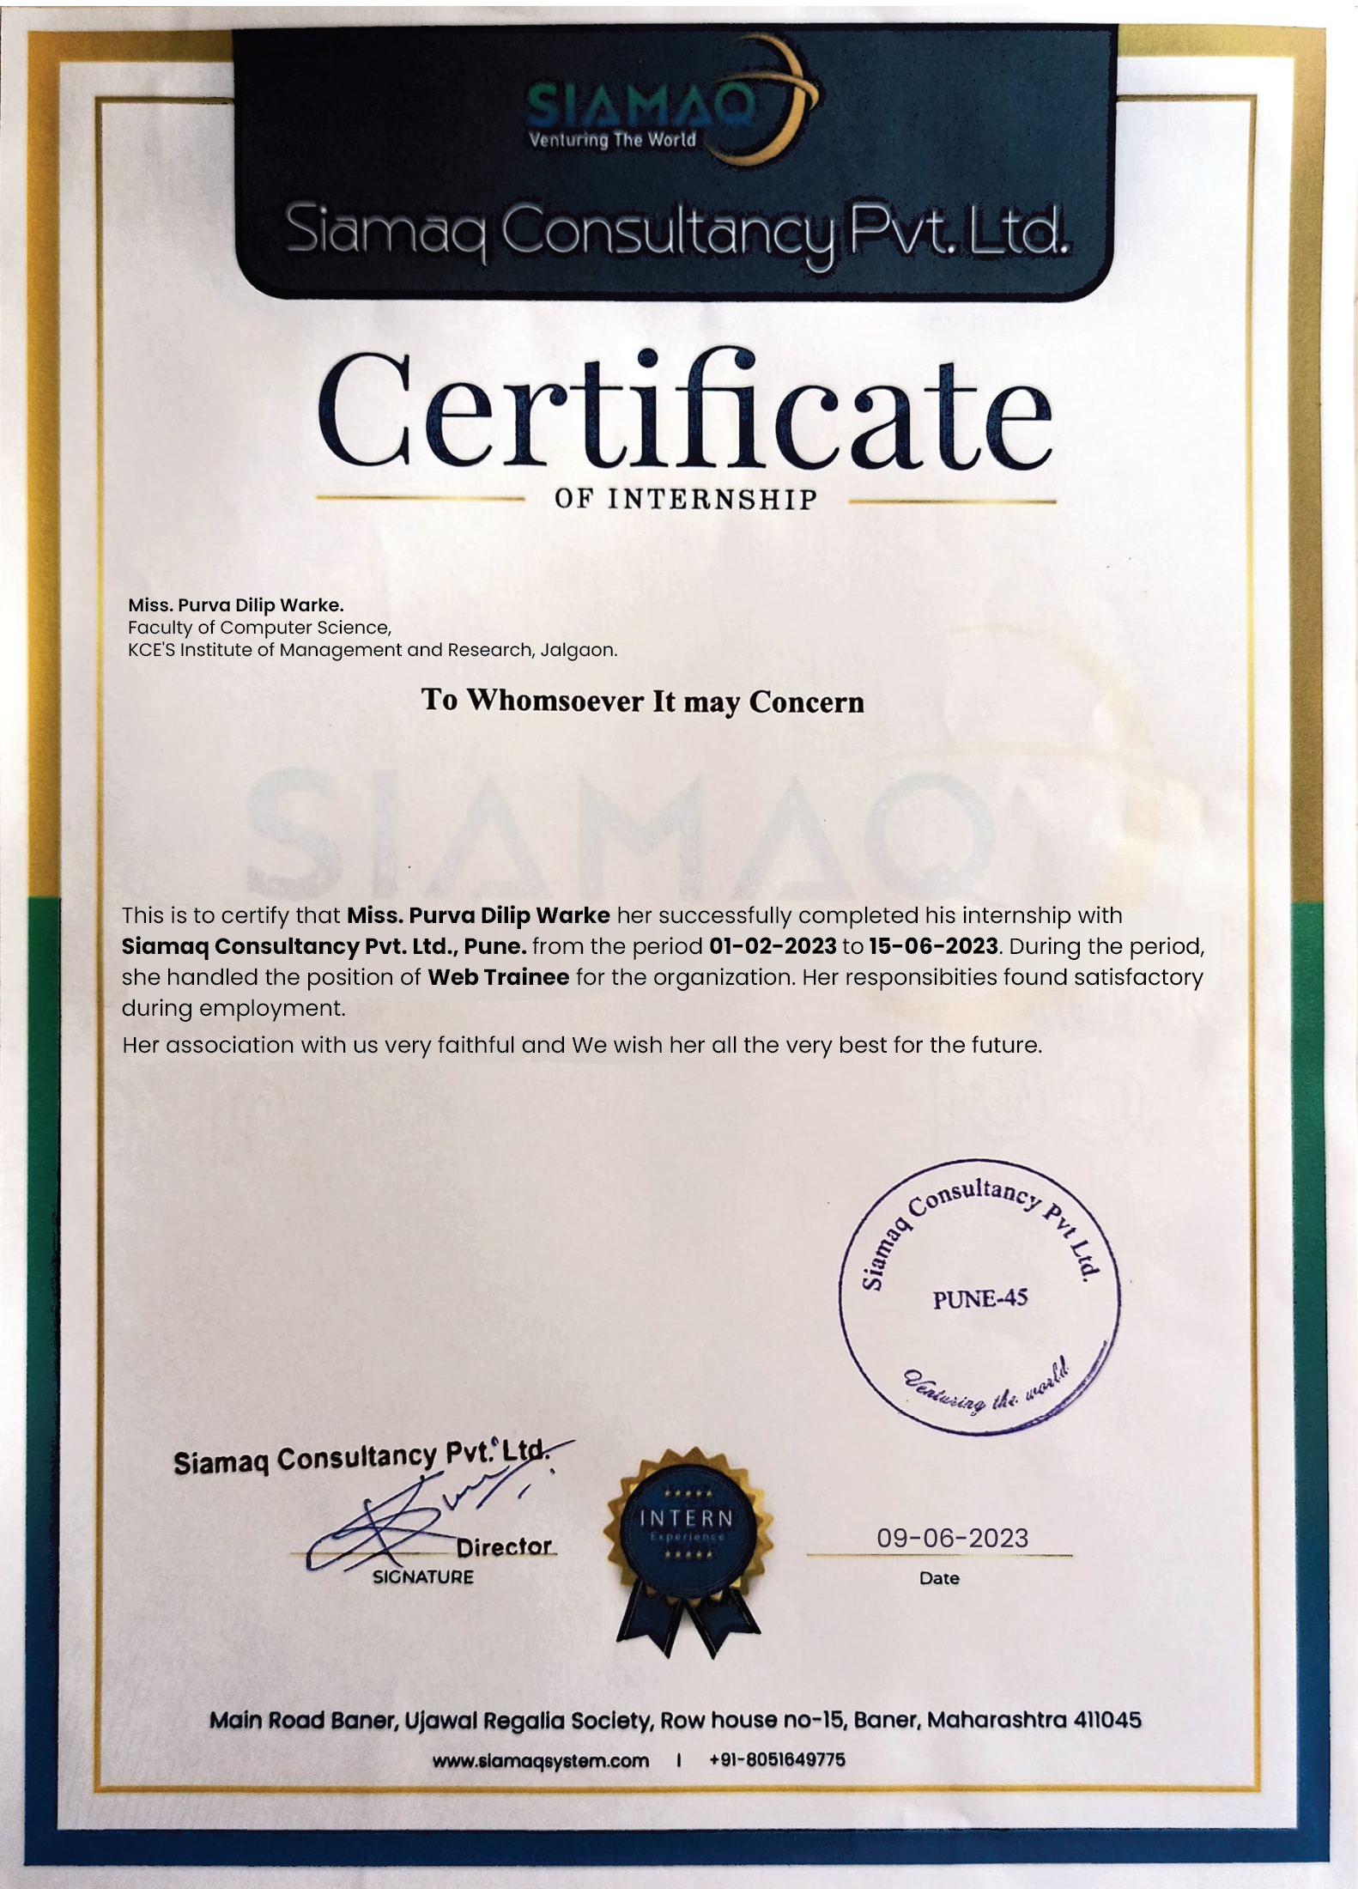

# Acknowledgment

I express a deep sense of gratitude towards **Mr. Arvind Bharadwaj Sir**, and **Ms. Shreya Shri** **Ma’am**, Project Head for providing me with the opportunity to work with “Siamaq Consultancy Pvt. Ltd., Pune”. I express my sincere thanks to **Ms. Ankita Tiwari** (Project Guide) for the encouragement, insistence, assistance, and valuable guidance in the completion of this project. I would like to thank **Mr. Nitesh Thakare Sir**, one or another way has helped me to learn the tricks and concepts of software development.

I would like to thank Director **Prof. Dr. Shilpa Kiran Bendale, HOD Dr. Tanuja Fegade ma’am** and **MCA coordinator Mr. Uday Chatur sir**, and all my faculty members who have been a constant source of inspiration to me throughout my completion of my MCA at the KCE's Institute of Management and Research, Jalgaon.

Miss. Purva Dilip Warke.

**Index**

|  |  |  |  |  |
| --- | --- | --- | --- | --- |
| **Sr. No.** | **Topic** | | | **Page No.** |
| **1.0** | **Introduction** | | |  |
|  | 1.1 | | Organization/Company Profile | 2 |
|  | 1.2 | | Introduction to Project / Outline | 4 |
| **2.0** | **System Requirement Analysis** | | |  |
|  | 2.1 | | Need and Motivation | 6 |
|  | 2.2 | | System Requirement Analysis | 7 |
|  | 2.3 | | Software Process and Development Model | 8 |
|  | 2.4 | | Hardware/ Software Specification | 10 |
| **3.0** | **Feasibility study** | | |  |
|  | 3.1 | | Technical Feasibility | 13 |
|  | 3.2 | | Economical Feasibility | 13 |
|  | 3.3 | | Operational Feasibility | 13 |
| **4.0** | **System Design** | | |  |
|  | 4.1 | Project Architecture | | 15 |
|  | 4.2 | Entity Relationship Diagram(s) | | 16 |
|  | 4.3 | Data Flow Diagrams | | 17 |
|  | 4.4 | Database Design / Data Dictionary | | 20 |
| **5.0** | **­­­Testing** | | |  |
|  | 5.1 | | Introduction of Testing | 25 |
|  | 5.2 | | Functionality Testing | 25 |
|  | 5.3 | | Compatibility Testing | 25 |
|  | 5.4 | | Security Testing | 25 |
|  | 5.5 | | Content Testing | 25 |
|  | 5.6 | | Regression Testing | 25 |
| **6.0** | **Concluding Remarks** | | |  |
|  | 6.1 | | Benefits | 27 |
|  | 6.2 | | Scope | 27 |
|  | 6.3 | | Limitations | 27 |
|  | 6.4 | | Strengths | 28 |
|  | 6.5 | | Weaknesses | 28 |
|  | 6.7 | | Future Work | 28 |
| **7.0** | **References** | | | 30 |
| **8.0** | **Appendix B** – Screen Layout | | | 32 |
|  | **Appendix C** – List of Tables | | | 54 |

**Chapter 1 – Introduction**

* 1. Organization / Company Profile
  2. Introduction to Project

## Organization / Company Profile :-

**Company Name :-** Siamaq Consultancy Pvt. Ltd.

**Location :-** R.H. N0 : 15, Ujjwal Regalia Society, Baner, Pune.

**Contact No :-** +91 8051649775

**Email :-** [**info@siamaqsystem.com**](mailto:info@siamaqsystem.com)

**Website :-https://www.siamaqsystem.com/**

## About Company :-

Siamaq Consultancy, a small IT company that provides business solutions around the world. Siamaq started its brand building journey in the year 2019. Our journey has been full of ups & downs, but we’ve overcome every huddle in our way with our sheer determination to deliver on our promises.

Siamaq Consultancy was started with small determined team of 03 and over the years we’ve grown from a team to a family of 50. We have mastered our skill set in all the domains and pioneer in delivering measurable results to our clientele.

Siamaq Consultancy Pvt. Ltd. is a fastest creating web progression association arranged in pune, India. Siamaq System Creates Bright and Functional Website Design for Businesses and Siamaq Consultancy Pvt. Ltd. is a fastest creating web progression association arranged in pune, India. Siamaq System Creates Bright and Functional Website Design for Businesses and Individuals.

Create world class digital presence with Siamaq consultancy. We are integrated marketing communication agency with capabilities and experience to grow and enhance your business both locally and globally. We are leading creative marketing agency specializing in branding, design and digital.

**Our Projects :-**

Our products and platforms are designed to help our clients accelerate their digital transformation journey through faster time to value, lower cost of operations, and deliver as a service.

**Website And Applications :-**

* + - * Metastake (metastakecoin.io)
      * Grrowmore (grrowmore.com)
      * MangoSweets (mangosweets.com)
      * TeamJiva (teamjiva.com)
      * SkyHighWin (skyhighwin.com)
      * Qudex (qudex.io)
      * Botfolio (botfoliotrade.co)

## Services Offered :-

* + - * **Digital marketing consulting services :-** Internet-based digital technologies are used in marketing to promote products and services.
      * **Web Design & Development: -** A website can be anything from a simple static page to a large web-based program.
      * **SEO Services :-** Digital Marketing Agency, we specialize in search engine optimization to help you become the leader in your domain.
      * **Mobile App Development :-** We work with both Android and IOS operating systems to help you build the apps of your dreams.
      * **Android Application Development Services :-** We have a dedicated & professional team of individuals who have expertise in developing the best quality of Mobile app.
      * **Video Marketing Services :-** We create from a digital marketing mindset ensuring that your video marketing campaign is innovative and effective.
      * **Content Marketing :-** most trusted and reliable content writing agency based in pune with highly experienced and professional content writers.
      * **Blockchain Technology :-** We develop various block-chain based products ranging from crypto currencies, crypto analysis tools, NFT’s, Meta-verse projects, Wallets etc.

## Our Culture:-

Every day, the self-motivated, dedicated individuals that work here help to shape our business culture. Our basic principles are vital to us and are reflected in how we collaborate with one another and with our clients. We work on hard and innovative projects at Siamaq Consultancy Pvt. Ltd., which drive our teams to do their best. Clients may expect value from Siamaq Consultancy.

## Introduction to Project: -

**Title :** Developing website for Siamaq Portal.

**Domain :** Web Technology.

**Front-End :** HTML, JSP, CSS, JavaScript, Bootstrap, jQuery.

**Back-End :** Java (Servlet), Tomcat-Server 9.0

### Project Objective : -

1. **“Siamaq Portal”** is a Clean Modern Web Based Website for **Online Job Hiring** to our company.
2. **Reduce Gap :** Siamaq Portal is to bridge the gap between job seekers and employers, facilitate efficient recruitment processes, and contribute to the growth and development of the employment ecosystem. By offering a robust platform for job postings, career resources, and seamless communication between employers and job seekers, Siamaq Portal tries to be a trusted and valuable resource for individuals seeking employment opportunities and companies searching for talented professionals.
3. **Job Seeker Engagement :** Create an engaging and user-friendly interface where job seekers can easily search and apply for available job positions within Siamaq Consultancy and other startup companies.
4. **Job Posting Platform :** Provide a platform for startup companies to post their job openings, allowing them to reach a wider audience and attract potential candidates.
5. **Support startup companies :** The website should provide a space for startup companies to post their job openings and attract talented individuals who are interested in working in a startup environment.
6. **Increase website traffic and user engagement :** Through effective marketing strategies, search engine optimization (SEO), and social media integration, the objective is to attract a steady flow of job seekers and companies to the website and encourage active participation.

**Chapter 2- System Requirement Analysis.**

2.1 Need & Motivation

2.2 System Requirement Analysis

* 1. Software process and Development Model

2.4 Hardware / Software Specification

## 2.1 Need and Motivation : -

## Needs : -

* + - To offers convenience and efficiency to both job seekers and employers.
    - To include resume-building guidance, interview tips, career advice articles, and access to industry news and updates.
    - to require a siamaq portal, where job seeker can easily browse and search for relevant job openings across multiple industries and sectors.
    - To addresses job seeker's need by hosting job postings from various companies and sectors.
    - To job seekers require accurate and up-to-date information about job vacancies, including job descriptions, requirements, and application deadlines. Siamaq Portal fulfills this need by providing detailed and comprehensive job listings.
    - Siamaq Portal provide a centralized and easily accessible platform for job seekers to explore a wide range of job opportunities.

## Motivation : -

* + - Job seekers are motivated to find meaningful employment that aligns with their skills, interests, and values. Siamaq Portal helps individuals discover job opportunities that resonate with their career aspirations, providing them with a sense of purpose and fulfillment in their work.
    - Job seekers are motivated to advance their careers and achieve professional growth.
    - Compared to traditional recruitment methods such as print advertisements or job fairs, job websites offer a more cost-effective solution.

## System Requirement and Analysis :-

### Functional Requirement :-

* + - The system should have a user-friendly interface.
    - The complete database resides on the server.
    - The user should be able to apply job without any hassle.
    - It should take less time to perform an action.

## Operational Requirement :-

* + - Proper validation checking at input time.
    - Generate records according to the requirement.
    - For using a system in the backend, the authentication ( using a Username and Password ) is checked.

## Performance Requirement :-

The system should be such that it stores the user input in an efficient and secure way and data available in a proper format on the screen.

## Design Constraints :-

* + - The design should be such that the web pages supports the proposed hardware for the system.
    - The users navigate to the home page from anywhere.
    - Each screen should contain the link button to move anywhere.

## Acceptance Criteria :-

* + - Before accepting the website, the developer must demonstrate the website works properly.
    - The developer will have to show through test cases that all conditions are working.

## Software Process and Development Model :-

### Software Process :-

A software process (also known as software methodology) is a set of related activities that leads to the production of the software. These activities may involve the development of the software from the scratch or modifying an existing system. Any software process must include the following four activities:

* **Software specification ( or requirements engineering ):-** Define the main functionalities of the software and the constraints around them.
* **Software design and implementation :-** The software is to be designed and programmed.
* **Software Verification and validation :-** The software must conform to its specification and meets the customer’s needs.
* **Software evolution (software maintenance): -** The software is being modified to meet customer and market requirements changes. In practice; they include sub-activities such as requirements validation, architectural design, unit testing, etc.

### Development Model:-

### Agile Model:-

* + - We are using this model because it Easy to manage.
    - Is a very realistic approach to software development.
    - Resource requirements are minimum.
    - Suitable for fixed or changing requirements
    - Involves pair programming which reduces the number of errors in the development or coding phase and is better than a single programmer doing all the hard part.
    - Efficient design and fulfils the business requirement.
    - Minimal rules, documentation easily employed.
    - Face-to-Face Communication with clients.
    - Anytime changes are acceptable.
    - It reduces total development time.

### Why we use Agile software model ?

During the project, end-user involvement is encouraged, providing visibility and transparency. There is continuous planning and feedback thought the process, delivering value to the business from the beginning of the project. Companies embrace this idea of delivering business value early in the process making it easier to lower risk associated with development.

### Advantages :-

* Gives flexibility to developers.
* It allows for regular communication and collaboration with stakeholders, enabling adjustments and refinements throughout the development process.
* After each iteration, customers and stakeholders of the project can get a fair idea the updated software that is being developed by the agile model. So, any change in the system can be addressed at any iteration.
* With Agile, websites can continuously improve their platform by incorporating user feedback, making iterative enhancements, and addressing issues in shorter development cycles. This iterative approach helps ensure that the website stays up-to-date and aligned with user expectations.
* Agile promotes cross-functional teams and encourages collaboration among members with different skill sets.

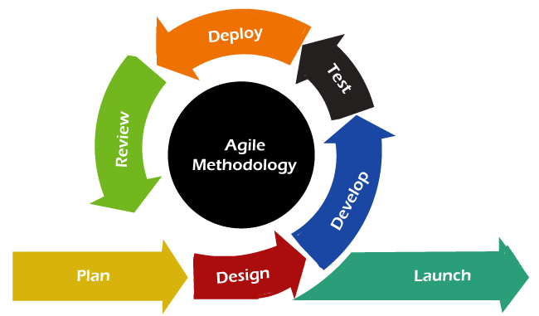

Fig 2.1 Agile Methodology Diagram

## Hardware / Software Specification Platform:-

### Minimum Software Requirement :-

* **Operating System**  **:** Windows 7,8,10,11, 32/ 64-bit.
* **Front end**  **:** HTML, CSS, JavaScript, jQuery, Bootstrap.
* **Back end** **:** Java, MySQL Database.
* **Development Tool** **:**  Eclipse, MySQL Workbench 8.0 CE
* **Sever** **:** Apache Tomcat 8.5.8
* **Browser** **:** Chrome or Firefox or Internet Explorer

### Minimum Hardware Requirement :-

* + - * **Processor :** Intel(R)Core(TM)
      * **HDD :** 10 GB
      * **Monitor :** Any Normal Monitor
      * **Mouse :** Any Normal Mouse

### Technologies Used:-

Detailed Description of Technology Used: -

* **HTML:-** HTML stands for Hypertext Markup Language, and it is the most widely used language to write Web Pages. HTML (Hypertext Markup Language) is a text-based approach to describing how content contained within an HTML file is structured. This markup tells a web browser how to display text, images and other forms of multimedia on a webpage. Does not have very dynamic functionality and is mainly used for static web pages. All components must be created separately even if they use similar elements.
  + - **CSS :-** Cascading **S**tyle **S**heets, fondly referred to as CSS, is a simple design language intended to simplify the process of making web pages presentable.CSS handles the look and feel part of a web page. Using CSS, you can control the color of the text, the style of fonts, the spacing between paragraphs, how columns are sized and laid out, what background images or colors are used, layout designs, variations in display for different devices and screen sizes as well as a variety of other effects.CSS is easy to learn and understand but it provides powerful control over the presentation of an HTML document.
    - **JavaScript :-** JavaScript is a high-level, interpreted programming language primarily used for creating dynamic and interactive web content. It is often referred to as the language of the web as it is widely supported by web browser. JavaScript is executed on the client-side, meaning it runs in the user's web browser, allowing for real-time interactions without requiring page reloads. It supports event-driven programming, where code is triggered by specific events like button clicks or mouse movements. JavaScript also provides powerful capabilities for manipulating the Document Object Model (DOM), allowing developers to modify page content and styles dynamically. It supports object-oriented programming principles, allowing for code organization and reusability
    - **jQuery :-** jQuery is a fast, lightweight, and feature-rich JavaScript library that simplifies web development tasks. It provides a concise and easy-to-use API for manipulating the Document Object Model (DOM), handling events, making AJAX requests, and animating elements on web pages. jQuery abstracts away many complexities of JavaScript, allowing developers to write less code while achieving powerful results. It is widely adopted and supported by major web browsers, making it a dependable choice for cross-browser compatibility. jQuery's popularity stems from its ability to streamline common web development tasks, enhance interactivity, and simplify complex operations, making it a go-to tool for developers looking to build dynamic and responsive websites.
    - **Bootstrap :-** Bootstrap is a popular front-end framework that provides a collection of CSS and JavaScript components for building responsive and mobile-friendly websites and web applications. It offers a comprehensive set of ready-to-use UI elements, such as buttons, forms, navigation menus, and grid layouts, which can be easily customized and styled to fit specific design needs. Bootstrap follows a mobile-first approach, ensuring that websites are optimized for smaller screens and progressively enhanced for larger ones. It also includes a responsive grid system that allows developers to create flexible and responsive layouts without the need for complex CSS coding.
    - **Java** :- Java is a versatile and widely-used programming language that has become a staple in the world of software development. It was first released by Sun Microsystems in 1995 and has since grown to become one of the most popular choices for building a wide range of applications, from desktop software to mobile apps and web services. Java's strength lies in its platform independence, allowing programs written in Java to run on any device or operating system that supports the Java Virtual Machine (JVM). With its object-oriented nature, robust libraries, and strong community support, Java continues to be a go-to language for beginners and experienced developers alike.
    - **Eclipse :-** Eclipse is a popular open-source IDE(Integrated Development Environment) for source code programming editors. In order to use eclipse effectively, we must familiar with the workbench, concepts, and components of Eclipse IDE. It contains plugins and a runtime system. It supports Windows, Linux, and macOS. By Default, support popular languages - JavaScript, NodeJS, typescript and Nodejs.
    - **MySQL Workbench :-** MySQL Workbench is a unified visual tool for database architects, developers, and DBAs. MySQL Workbench provides data modeling, SQL development, and comprehensive administration tools for server configuration, user administration, backup, and much more. MySQL Workbench is available on Windows, Linux and Mac OS X.
    - **Apache Tomcat :-** The Apache Tomcat® software is an open source implementation of the [Jakarta Servlet](https://projects.eclipse.org/projects/ee4j.servlet), [Jakarta Server Pages](https://projects.eclipse.org/projects/ee4j.jsp), [Jakarta Expression Language](https://projects.eclipse.org/projects/ee4j.el), [Jakarta WebSocket](https://projects.eclipse.org/projects/ee4j.websocket), [Jakarta Annotations](https://projects.eclipse.org/projects/ee4j.ca) and [Jakarta Authentication](https://projects.eclipse.org/projects/ee4j.authentication) specifications. These specifications are part of the platform. The Jakarta EE platform is the evolution of the Java EE platform. Tomcat 10 and later implement specifications developed as part of Jakarta EE. Tomcat 9 and earlier implement specifications developed as part of Java EE. The Apache Tomcat software is developed in an open and participatory environment and released under the [Apache License version 2](http://www.apache.org/licenses/). The Apache Tomcat project is intended to be a collaboration of the best-of-breed developers from around the world.

**Chapter 3-Feasibility Study.**

3.1 Introduction

3.2 Technical Feasibility

3.3 Economical Feasibility

3.4 Operational Feasibility­­

**3.1 Introduction:**

A feasibility study is the initial study of the project. The feasibility study meant gathering all the information related to the project. Study the project at the initial level.

A Feasibility Study determines whether a project is worth doing. The process followed for making this determination is called a Feasibility Study. This type of study determines whether a project can and should proceed. Once it has been determined that a project is feasible, the analyst can proceed and prepare the project specifications that finalize the project specification.

The following are the various types of feasibility studies that can be undertaken.

## 3.2 Technical Feasibility :-

The Software is developed using the Eclipse IDE i.e., Html front end and MySQL workbench 8.2 CE as backend tool. The user requirement for the project was multidimensional and hence it has to be a web-based application such that the application be launched on a particular web server and users be it a client or a developer or a tester can perform his work as per requirements i.e., all users of the system can do work on same work request simultaneously within his domain. Thus, it can be stated that the system is technically feasible.

## 3.3 Economical Feasibility :-

Operation feasibility is used to check whether the project is operationally feasible or not. Our project is mainly different from the other system because of its web-support feature. So the measure for operational feasibility is something different from other system. Generally the operational feasibility is related to organization aspects. The change determination is as such that early product were either a man or group of men or the jobs based manual but now a day with the advent of Internet technology.

## 3.4 Operational Feasibility:

The System is easy to handle and there is no need for any special training to anybody to handle the system. To handle the system the user need not be a computer professional, on the whole the company will benefit from the system and hence the system is operationally feasible. Operational feasibility Analysis checks proposed project meets the Organization’s operational requirements or not.

**Chapter 4 - System Design.**

* 1. Project Architecture/Modular Design Diagram
  2. Entity Relationship Diagram
  3. Data Flow Diagram
  4. Database Design/Data Dictionary

**4.1 Project Architecture / Modular Design Diagram :-**

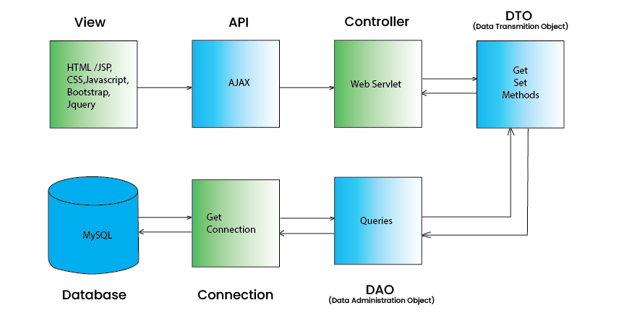

Fig 4.1. Project Architecture Diagram

**4.2 Entity Relationship Diagram (ERD) :-**

An entity relationship diagram (ERD) shows the relationships of entity sets stored in a database. An entity in this context is an object, a component of data. An entity set is a collection of similar entities. These entities can have attributes that define its properties. By defining entities, their attributes, and showing the relationships between them, an ER diagram illustrates the logical structure of databases.

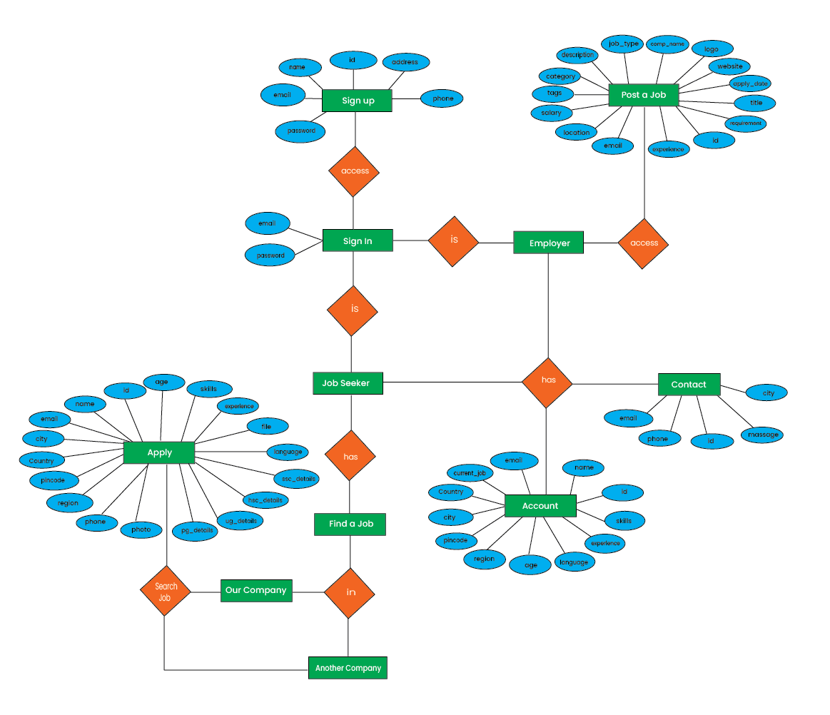­

Fig 4.2. Entity Relationship Diagram ( ERD )

**4.3 Data Flow Diagram (DFD) :-**

A data flow diagram (DFD) maps out the flow of information for any process or system. It uses defined symbols like rectangle, circle, and arrow, plus a short text label, to show data inputs, outputs, storage points, and routes between each destination. Data flowcharts can range from simple, even hand-drawn process overviews, to in-depth, multi-level DFDs that dig progressively deeper into how the data is handled. They can be used to analyze an existing system or model a new one.

* **Level 0 Data-Flow Diagram**

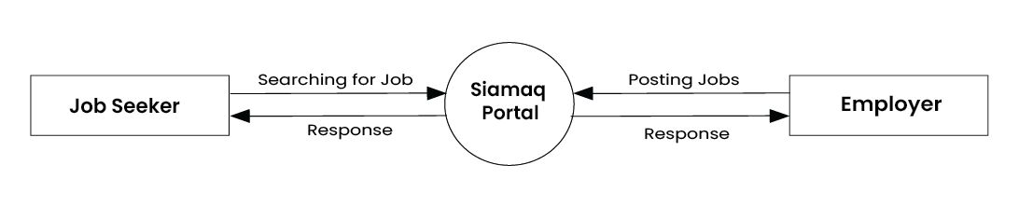

Fig 4.3. Level 0 Data-Flow Diagram

* **Level 1 Data-Flow Diagram for Sign-up**

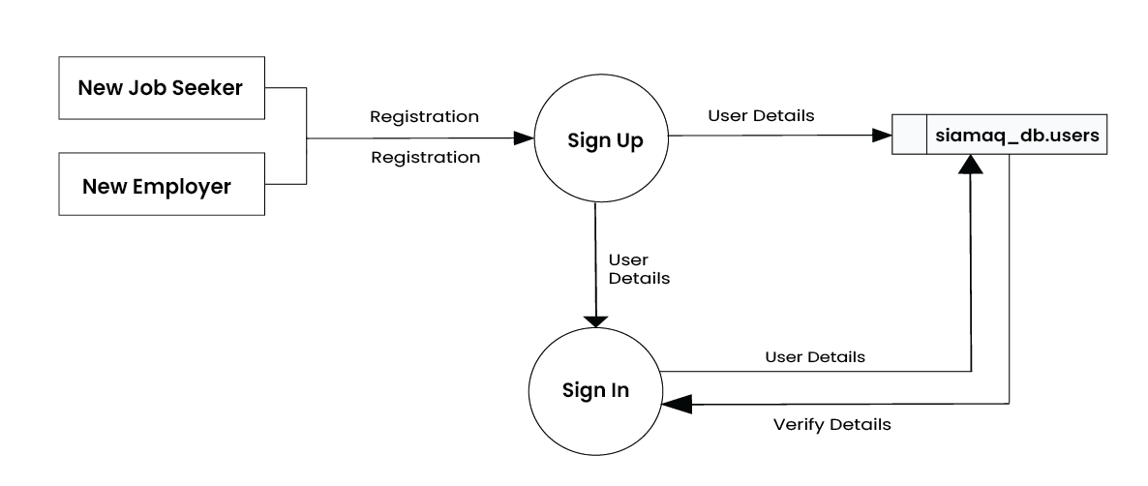

Fig 4.4. Level 1 Data-Flow Diagram for Sign-up

* **Level 1 Data-Flow Diagram for Sign-in**

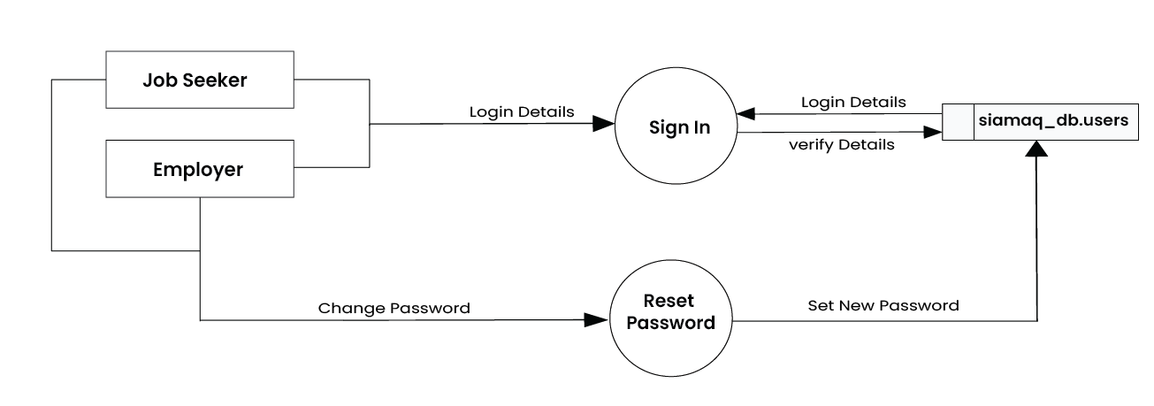

Fig 4.5. Level 1 Data-Flow Diagram for Sign-in

* **Level 2 Data-Flow Diagram for Job Seeker**

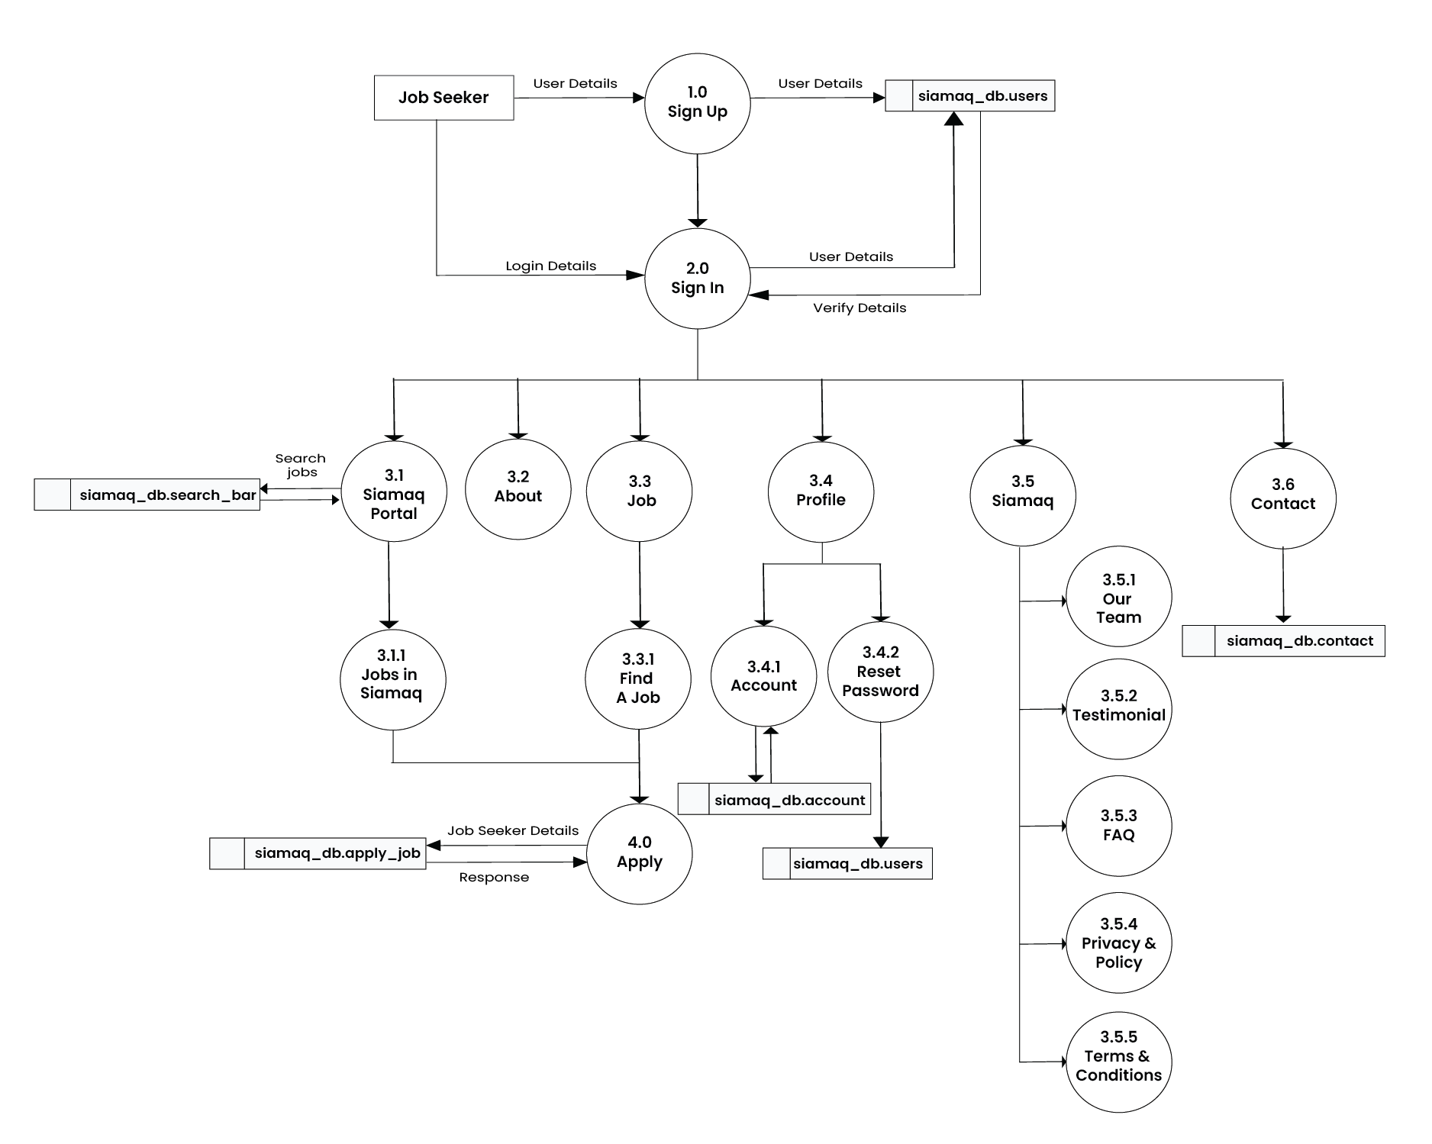

Fig 4.6. Level 1 Data-Flow Diagram for Job Seeker

* **Level 2 Data-Flow Diagram for Employer**

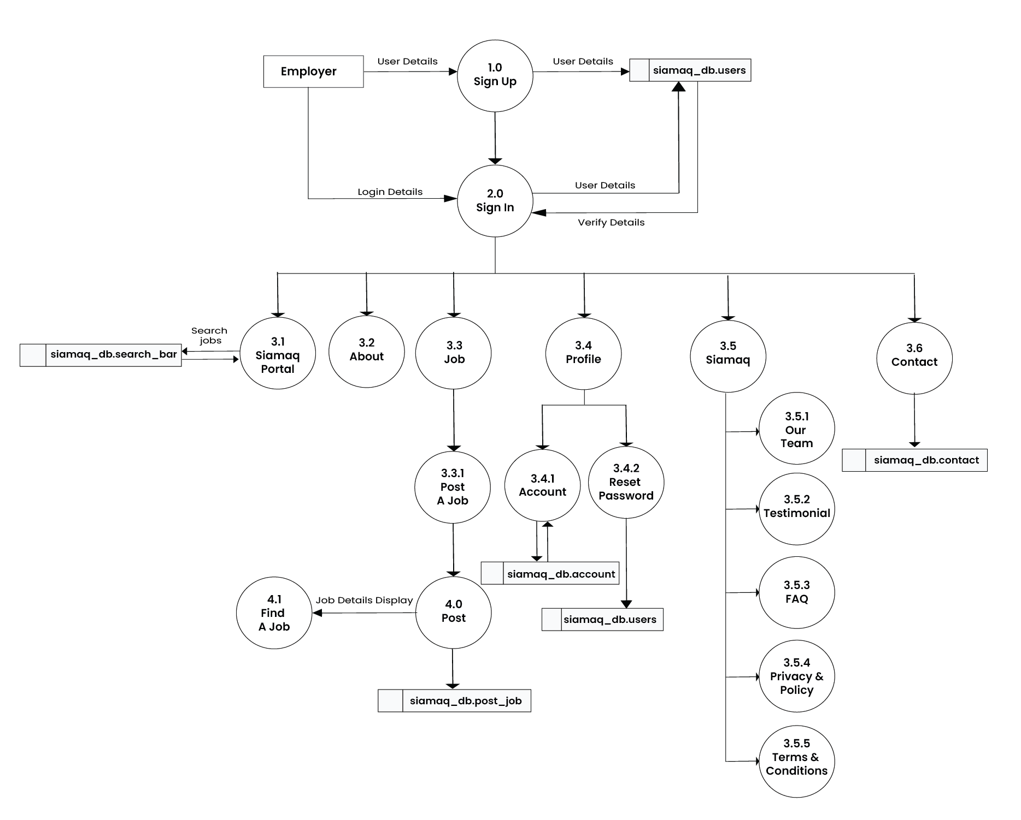

Fig 4.7. Level 2 Data-Flow Diagram for Employer

**4.4 Data Dictionary**

* **Table : siamaq.db_user**

|  |  |  |  |  |
| --- | --- | --- | --- | --- |
| **SR.NO** | **FIELDS** | **TYPE** | **SIZE** | **CONSTRAINT** |
| 1 | ID | INT | 20 | PRIMARY KEY |
| 2 | FULL NAME | VARCHAR | 50 | NOT NULL |
| 3 | PASSWORD | VARCHAR | 50 | NOT NULL |
| 4 | EMAIL | VARCHAR | 20 | NOT NULL |
| 5 | PHONE_NO | VARCHAR | 10 | NOT NULL |
| 6 | ROLE | VARCHAR | 20 | NOT NULL |

* **Table : siamaq.db_search_bar**

|  |  |  |  |  |
| --- | --- | --- | --- | --- |
| **SR.NO** | **FIELDS** | **TYPE** | **SIZE** | **CONSTRAINT** |
| 1 | ID | INT | 20 | PRIMARY KEY |
| 2 | JOB_TITLE | VARCHAR | 50 | NOT NULL |
| 3 | LOCATION | VARCHAR | 50 | NOT NULL |
| 4 | CATEGORY | VARCHAR | 20 | NOT NULL |

* **Table: siamaq.db_subscribe**

|  |  |  |  |  |
| --- | --- | --- | --- | --- |
| **SR.NO** | **FIELDS** | **TYPE** | **SIZE** | **CONSTRAINT** |
| 1 | ID | INT | 20 | PRIMARY KEY |
| 2 | EMAIL | VARCHAR | 50 | NOT NULL |

* **Table : siamaq.db_apply_job**

|  |  |  |  |  |
| --- | --- | --- | --- | --- |
| **SR.NO** | **FIELDS** | **TYPE** | **SIZE** | **CONSTRAINT** |
| 1 | ID | INT | 20 | FOREIGN KEY |
| 2 | NAME | VARCHAR | 50 | NOT NULL |
| 3 | EMAIL | VARCHAR | 50 | NOT NULL |
| 4 | PHONE_NO | INT | 50 | NOT NULL |
| 5 | TITLE | VARCHAR | 20 | NOT NULL |
| 6 | COUNTRY | VARCHAR | 10 | NOT NULL |
| 7 | CITY | VARCHAR | 100 | NOT NULL |
| 8 | PINCODE | INT | 10 | NOT NULL |
| 9 | REGION | VARCHAR | 50 | NOT NULL |
| 10 | PG_DEGREE | VARCHAR | 50 | NOT NULL |
| 11 | PG_UNIVERSITY | VARCHAR | 50 | NOT NULL |
| 12 | PG_GRADE | FLOAT | 4 | NOT NULL |
| 13 | PG_YEAR | INT | 10 | NOT NULL |
| 14 | UG_DEGREE | VARCHAR | 50 | NOT NULL |
| 15 | UG_UNIVERSITY | VARCHAR | 50 | NOT NULL |
| 16 | UG_GRADE | FLOAT | 4 | NOT NULL |
| 17 | UG_YEAR | INT | 10 | NOT NULL |
| 18 | HSC_BOARD | VARCHAR | 50 | NOT NULL |
| 19 | HSC_GRADE | FLOAT | 10 | NOT NULL |
| 20 | HSC_YEAR | INT | 10 | NOT NULL |
| 21 | SSC_BOARD | VARCHAR | 50 | NOT NULL |
| 22 | SSC_GRADE | FLOAT | 10 | NOT NULL |
| 23 | SSC_YEAR | INT | 10 | NOT NULL |

* **Table: siamaq.db_post_job**

|  |  |  |  |  |
| --- | --- | --- | --- | --- |
| **SR.NO** | **FIELDS** | **TYPE** | **SIZE** | **CONSTRAINT** |
| 1 | ID | INT | 20 | FOREIGN KEY |
| 2 | TITLE | VARCHAR | 50 | NOT NULL |
| 3 | COMP_NAME | VARCHAR | 50 | NOT NULL |
| 4 | WEBSITE | VARCHAR | 50 | NOT NULL |
| 5 | JOB_TYPE | VARCHAR | 20 | NOT NULL |
| 6 | DESCRIPTION | VARCHAR | 1000 | NOT NULL |
| 7 | CATEGORY | VARCHAR | 20 | NOT NULL |
| 8 | SALARY | INT | 10 | NOT NULL |
| 9 | EMAIL | VARCHAR | 20 | NOT NULL |
| 10 | LOCATION | VARCHAR | 20 | NOT NULL |
| 11 | TAGS | VARCHAR | 50 | NOT NULL |
| 12 | EXPERIENCE | FLOAT | 10 | NOT NULL |
| 13 | REQUIREMENT | VARCHAR | 1000 | NOT NULL |
| 14 | APPLY_DATE | VARCHAR | 50 | NOT NULL |
| 15 | LOGO | BLOG | - | NOT NULL |

* **Table : siamaq.db_contact**

|  |  |  |  |  |
| --- | --- | --- | --- | --- |
| **SR.NO** | **FIELDS** | **TYPE** | **SIZE** | **CONSTRAINT** |
| 1 | ID | INT | 20 | FOREIGN KEY |
| 2 | NAME | VARCHAR | 50 | NOT NULL |
| 3 | PHONE | INT | 10 | NOT NULL |
| 4 | EMAIL | VARCHAR | 20 | NOT NULL |
| 5 | CITY | VARCHAR | 50 | NOT NULL |
| 6 | MESSAGE | VARCHAR | 100 | NOT NULL |

* **Table: siamaq.db_account**

|  |  |  |  |  |
| --- | --- | --- | --- | --- |
| **SR.NO** | **FIELDS** | **TYPE** | **SIZE** | **CONSTRAINT** |
| 1 | ID | INT | 20 | FOREIGN KEY |
| 2 | NAME | VARCHAR | 50 | NOT NULL |
| 3 | EMAIL | VARCHAR | 50 | NOT NULL |
| 4 | CURRENT_JOB | VARCHAR | 20 | NOT NULL |
| 5 | COUNTRY | VARCHAR | 10 | NOT NULL |
| 6 | CITY | VARCHAR | 100 | NOT NULL |
| 7 | PINCODE | VARCHAR | 10 | NOT NULL |
| 8 | REGION | VARCHAR | 50 | NOT NULL |
| 9 | AGE | INT | 10 | NOT NULL |
| 10 | LANGUAGE | VARCHAR | 50 | NOT NULL |
| 11 | EXPERIENCE | INT | 10 | NOT NULL |
| 12 | SKILLS | VARCHAR | 50 | NOT NULL |

**Chapter 5 - Testing.**

* 1. Introduction to Testing
  2. Functionality Testing
  3. Compatibility Testing
  4. Security Testing
  5. Content Testing
  6. Regression Testing
  7. **Introduction:-**

Software Testing is an essential process that evaluates a software system against user requirements and system specifications. It plays a vital role in the success of any system, ensuring that it meets the intended purpose. By validating and verifying the software, we can achieve our goals effectively. During the testing phase, we determine if the program performs as expected by executing a series of tests. We conduct thorough testing before the system is ready for user acceptance, ensuring its quality and reliability.

* 1. **Functionality Testing :-**

This type of testing focuses on verifying that all the features and functions of the website are working correctly. It involves testing various user interactions, form submissions, navigation, links, and data processing.

* 1. **Compatibility Testing :-**

Compatibility testing ensures that the website functions as intended across different browsers, operating systems, and devices. It involves testing on various combinations of browsers, operating systems and screen sizes/resolutions.

* 1. **Security Testing :-**

Security testing aims to identify vulnerabilities and ensure the website is protected against potential threats. It involves testing for issues such as SQL injection, cross-site scripting (XSS), cross-site request forgery (CSRF), authentication and authorization vulnerabilities, data encryption, and secure connections (HTTPS).

* 1. **Content Testing :-**

Content testing ensures that all text, images, multimedia, and other content elements are displayed correctly and consistently across the website. It includes checking for formatting issues, broken links, missing or incorrect content, and language localization if applicable.

* 1. **Regression Testing :-**

Regression testing is performed after making changes or updates to the website to ensure that the existing functionalities are still working as expected. It involves retesting previously tested features to catch any regressions or unintended side effects.

**Chapter 6 – Concluding Remark**

6.1 Benefits

6.2 Scope

6.3 Limitations

6.4 Strength

6.5 Weakness

6.6 Future Work

**6.1 Benefits :-**

1. **Wide Range of Job Opportunities :**- The job portal provides access to a diverse range of job opportunities across various industries and sectors. Job seekers can explore a wide array of positions that match their skills, qualifications, and career goals.
2. **Easy Application Process :-** Job seekers can apply for jobs directly through the portal, eliminating the need for traditional application methods like mailing physical resumes. They can create online profiles, upload resumes, and submit applications with just a few clicks, making the process quick and convenient.
3. **Enhanced Visibility for Job Seekers :-** The job portal increases job seekers' visibility to potential employers. By creating an online profile and uploading their resume, they can showcase their skills, experience, and qualifications to companies actively seeking talent.
4. **Efficient Recruitment for Companies :-** The portal simplifies the recruitment process for companies. Employers can create detailed job postings, specify required qualifications, and receive applications directly through the platform. This streamlines the hiring process and helps companies find suitable candidates more efficiently.
5. **Time and Cost Savings :-** Using the job portal saves both job seekers and companies time and costs associated with traditional recruitment methods. Job seekers can apply to multiple positions with ease, while companies can reach a wider pool of candidates without the need for extensive advertising or manual application screening.

**6.2 Scope :-**

As of Indian market, there is ample opportunities for the job portal sites, as more and more number of educated and skilled young people are coming out each and every year. Also, as the growth rate of India is zooming to be at a healthy rate over 7%, so it is boom time for corporate also. So, more and more number of lucrative careers will be available for the job seekers. So, it is now the right period for the job portal sites to think out of the box, and to make most of the opportunities available.

**6.3 Limitations :-**

* The size of the database increases day-by-day, increasing the load on the database back up and data maintenance activity.
* Poor communication as a result of being unable to respond to each applicant throughout the process to ensure a positive candidate experience.

**6.4 Strengths :-**

### Some companies are worry of hiring employee's so this site is best for them to hiring employee's in there company's.

* Anyone can post a job online because the process clear, easy to understand and user-friendly. Conversely, the process is very simple for the applicant, too, making it quick and painless for interested parties to apply on the spot instead of mailing CVs and written applications through the post.

**6.5 Weaknesses :-**

* They have no screening. Anyone can sign up for a profile and apply for a job on an online job portal - no matter their credentials. With no official screening process in place, the website you’re using can allow unlimited unqualified candidates to apply. Reviewing unqualified applications is an even further waste of your time.
* They’re ineffective for high-level positions. Because they have no screening process and allow companies to post for a wide variety of jobs, online job search websites tend to be better choices for entry-level positions. Your high-level position won’t get the attention or the kind of candidates you need.

**6.7 Future Work :-**

This project fulfils the primary requirements of the job seekers and employers. It can be extended in several ways – We can provide recommendations and email updates for new job postings based on the job seeker’s search history. Since, the job seekers might be interested in building a strong Resume, we can provide tips and information for the same. We can also provide templates for building the Resumes which might interest most applicants. The mobile application is developed fulfilling the functionalities of job seeker, it can be extended to support functionalities of Employer as well.

**Chapter 7 – References**

7.1 For a Books

7.2 For a website

**For a Books :-**

* + 1. "**Learning Web Design**" by Jennifer Niederst Robbins.
    2. "**JavaScript** " by Michael Moncur.
    3. "**Database Systems**" by Thomas Connolly and Carolyn Begg.
    4. "**Bootstrap 4 Quick Start**" by Jacob Lett.
    5. "**MySQL Cookbook**" by Paul DuBois.
    6. **“HTML5 and CSS3”** by Elizabeth Castro & Bruce Hyslop.

**For a website :-**

During the Development of the Project, I have referred following Websites are:-

* 1. <https://www.usajobs.gov/>
  2. <https://www.careerbuilder.com/regional_sites>
  3. <https://www.ziprecruiter.co.uk/?utm_source=ziprecruiter-com-redirect>
  4. <https://www.visual-paradigm.com/tutorials/data-flow-diagram-dfd.jsp>
  5. <https://www.linkedin.com/jobs>
  6. <https://www.naukri.com/mnjuser/homepage>
  7. <https://www.siamaqsystem.com/>
  8. <https://www.w3schools.in/sdlc/agile-model>
  9. <https://www.w3schools.com/html/>
  10. [https://www.startbootstrap.com](https://www.startbootstrap.com/)
  11. <https://www.javatpoint.com/>
  12. <http://www.indeed.com/>

**Chapter 8 – Appendix**

B – Screen Layout

C – List of Tables

**8. Appendix B – Screen Layout**

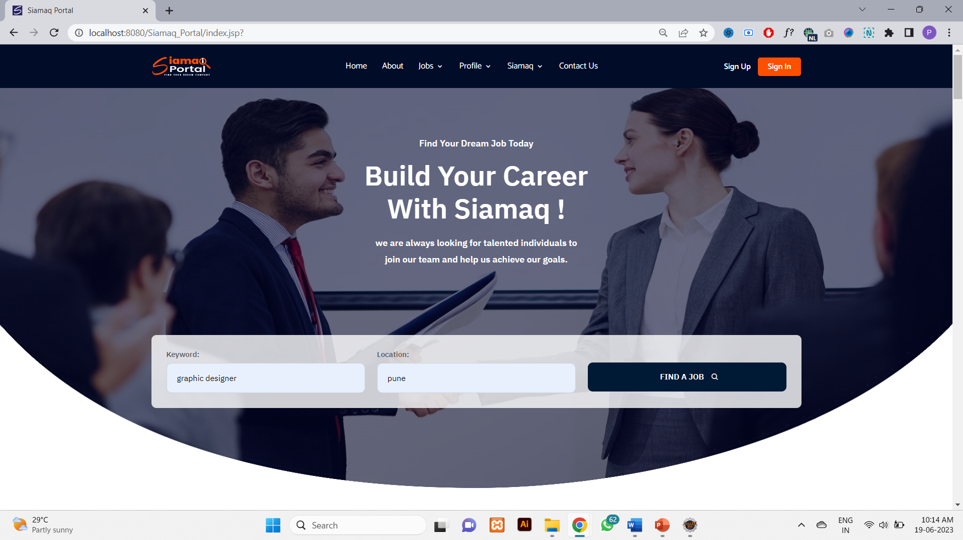

Fig 1.1 Home Page ( Main & Search Section )

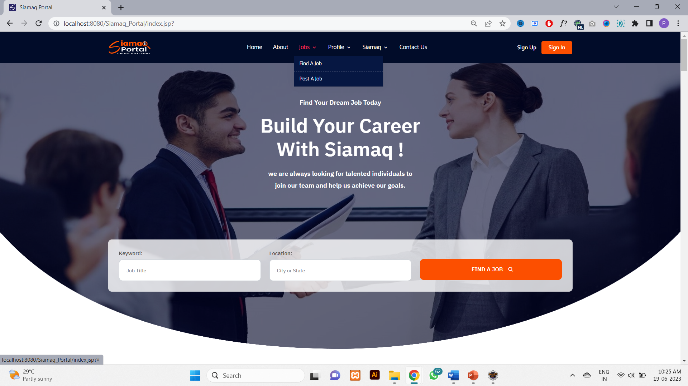

Fig 1.1 Home Page ( Header Section )

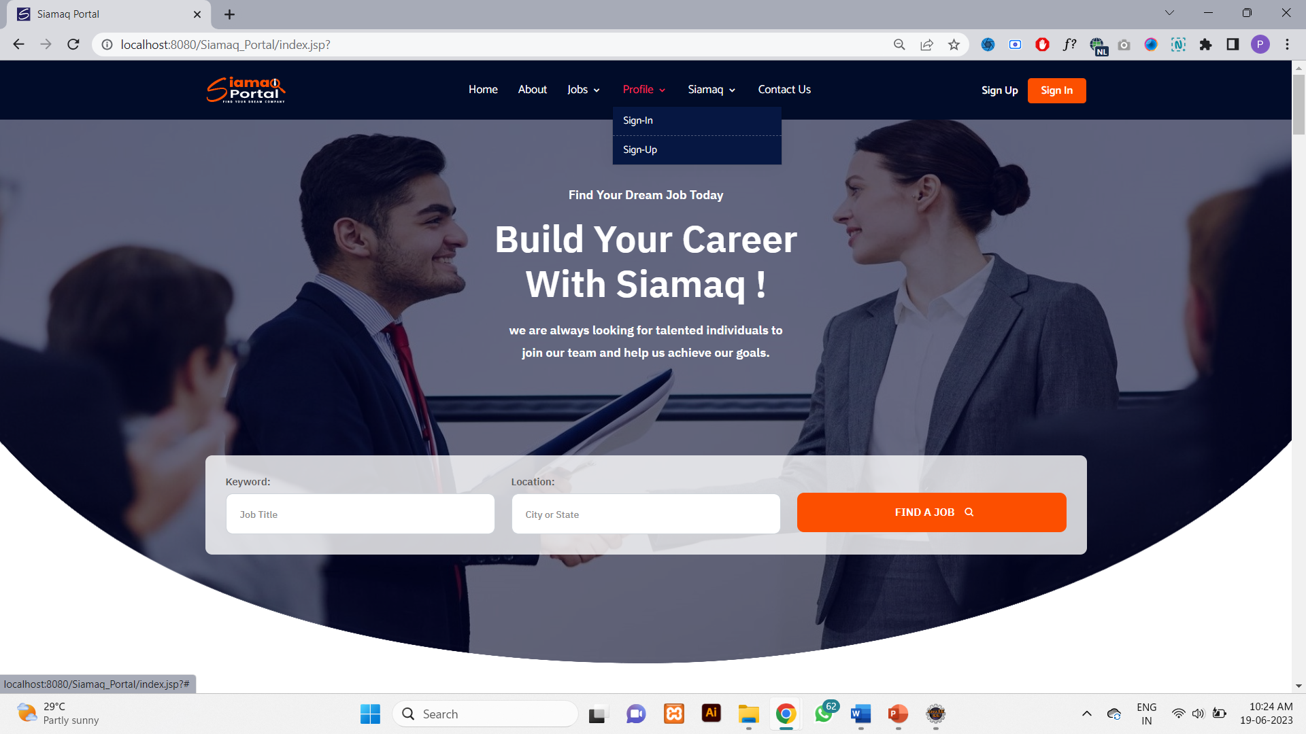

Fig 1.1 Home Page ( Header Section )

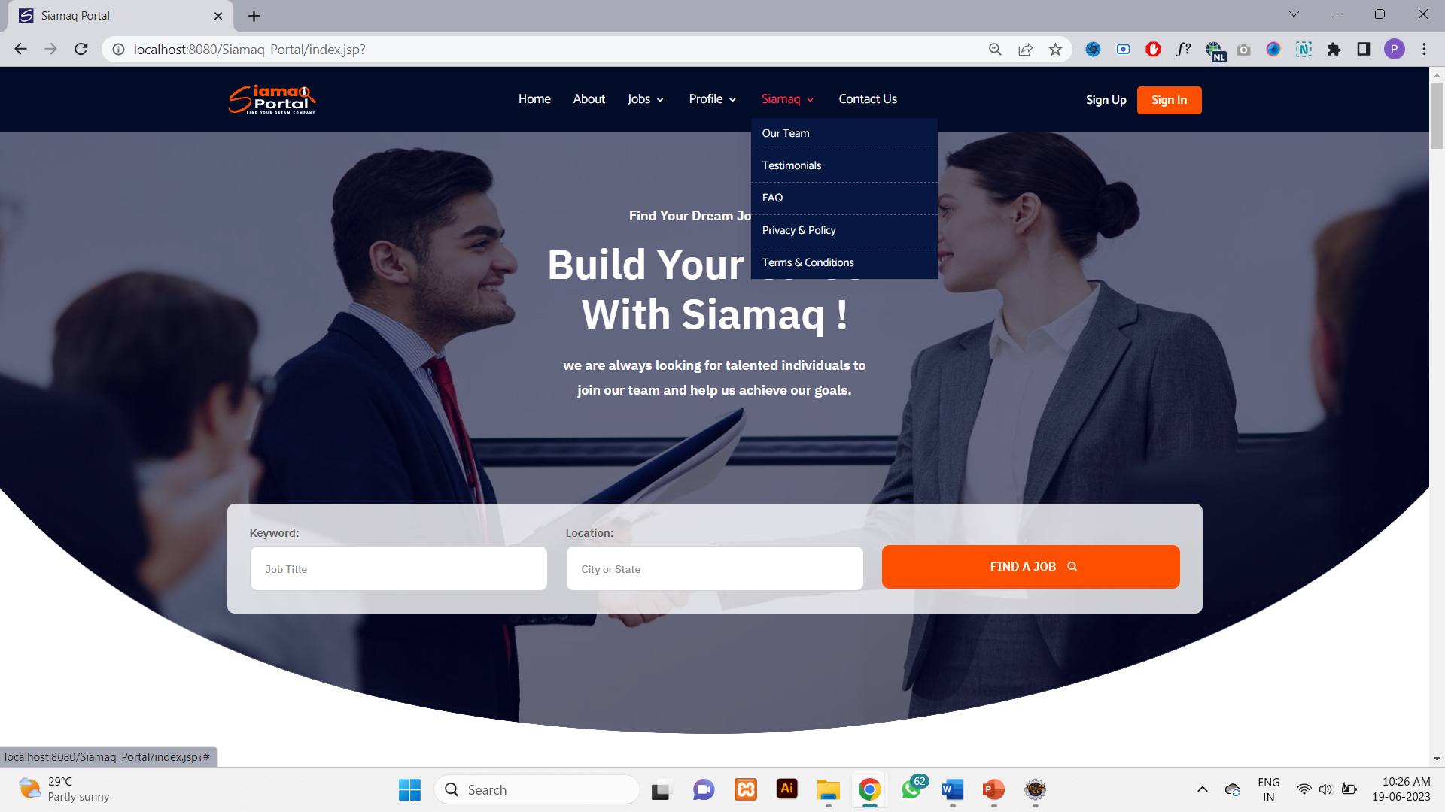

Fig 1.1 Home Page ( Header Section )

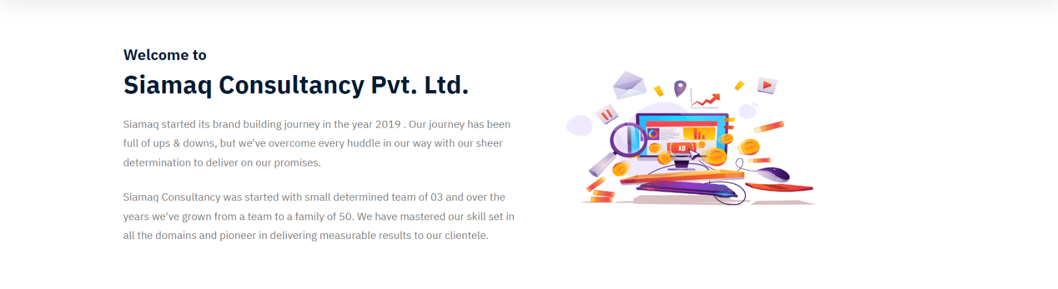

Fig 1.1 Home Page ( About Section )

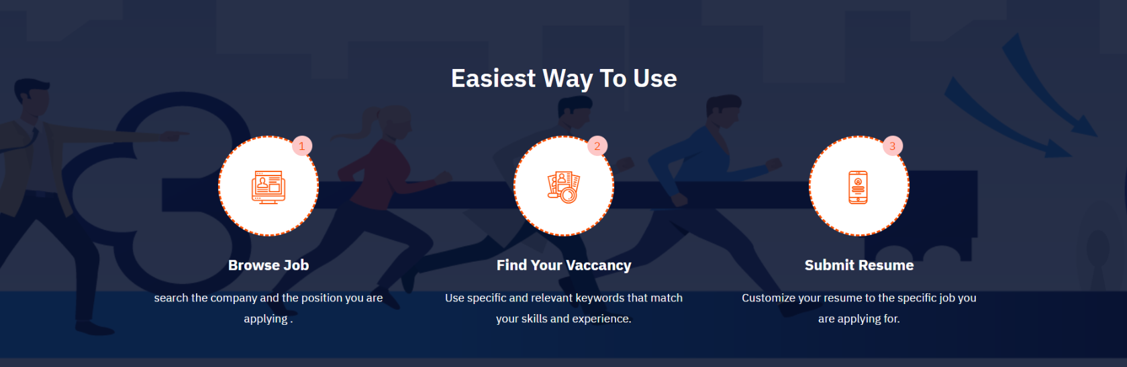

Fig 1.1 Home Page ( Easiest Way TO Use Section )

­­­

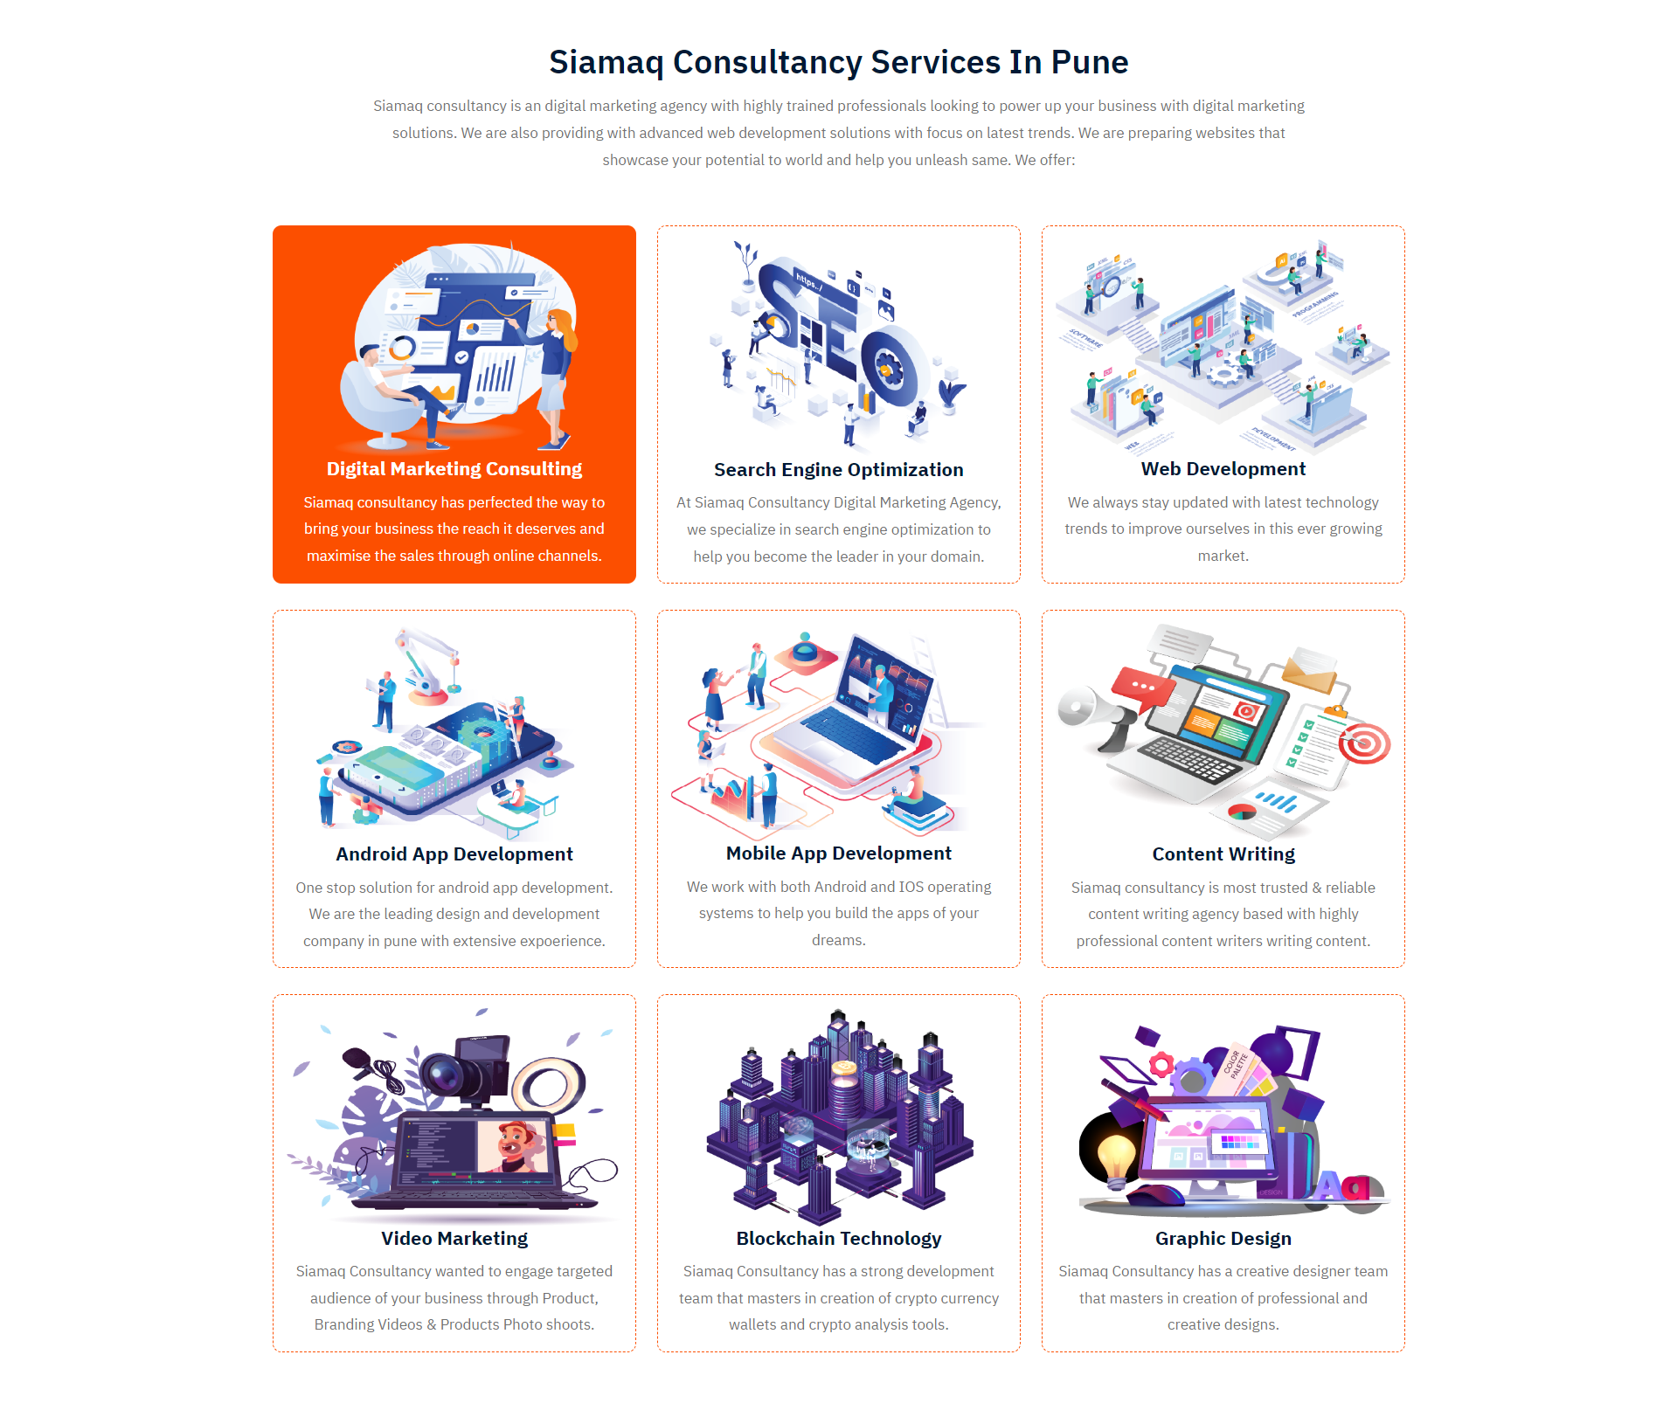

Fig 1.1 Home Page ( Services Section )

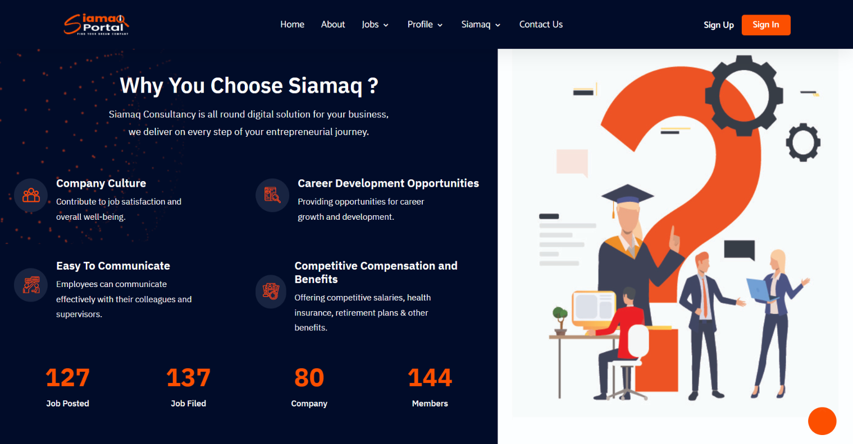

Fig 1.1 Home Page ( Why You Choose Siamaq Section )

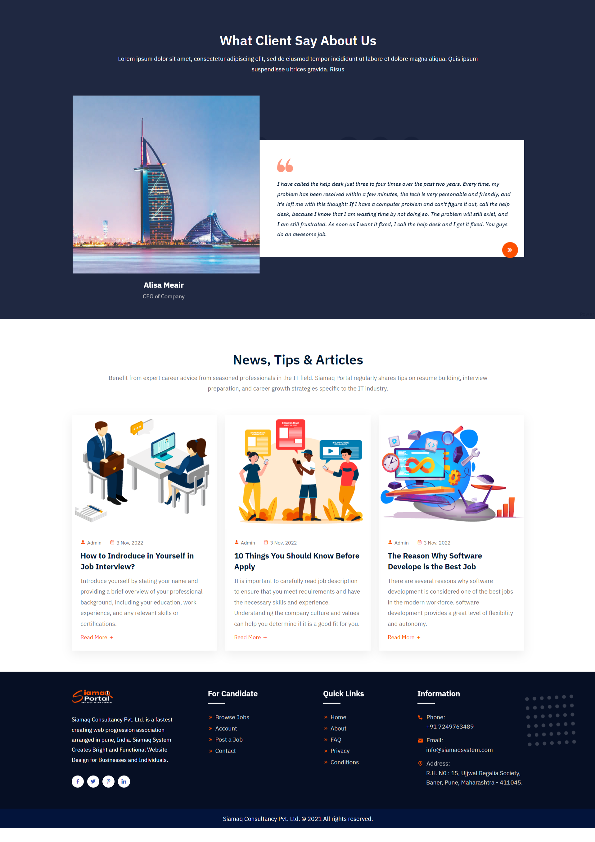

Fig 1.1 Home Page ( What Client Says Section )

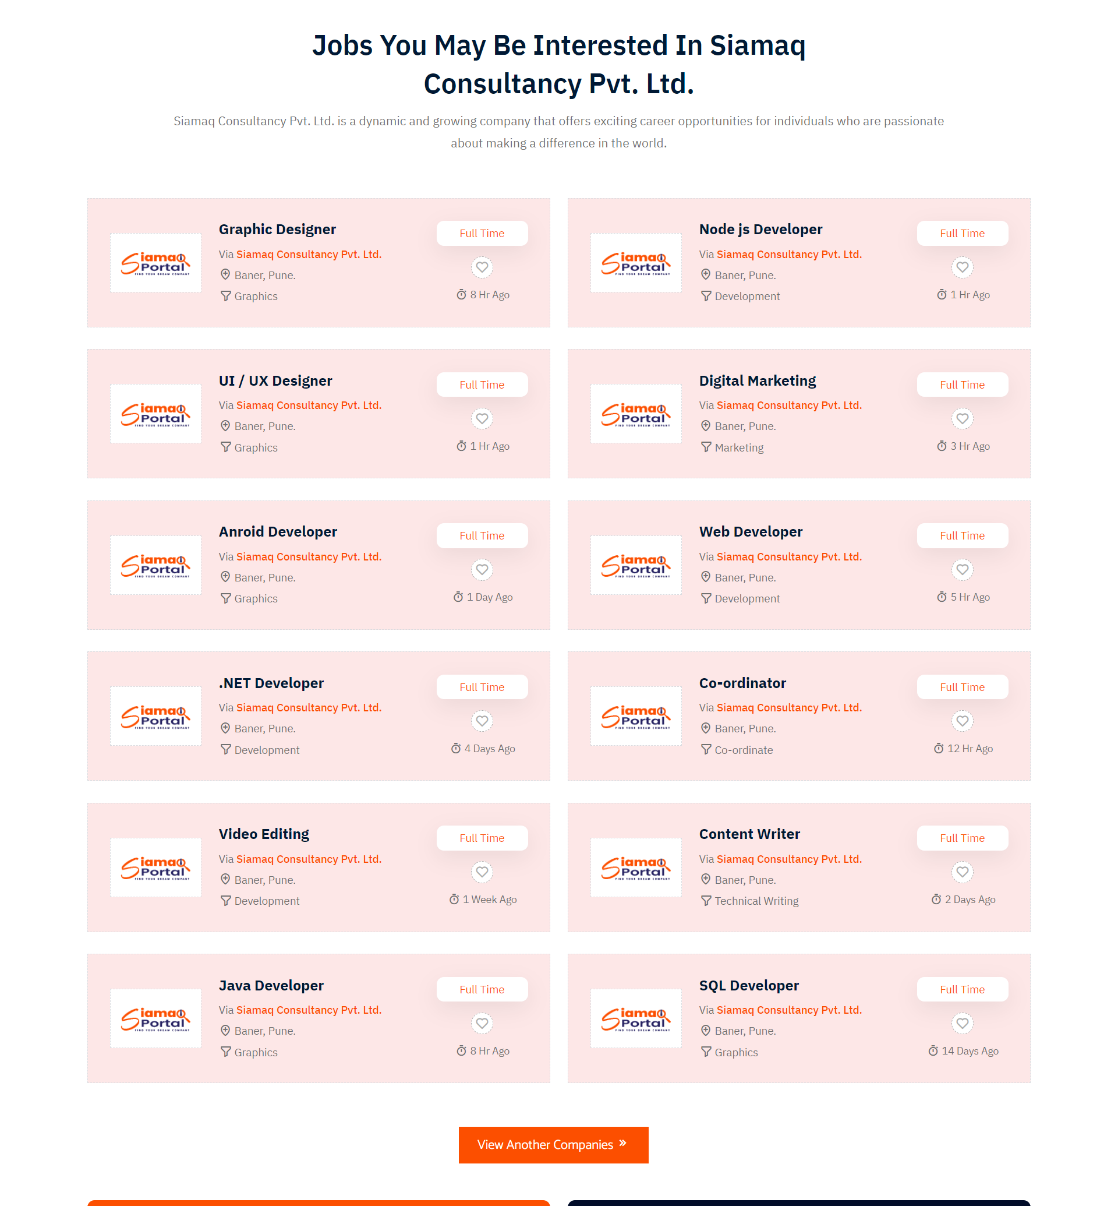

Fig 1.1 Home Page ( Jobs in Siamaq Section )

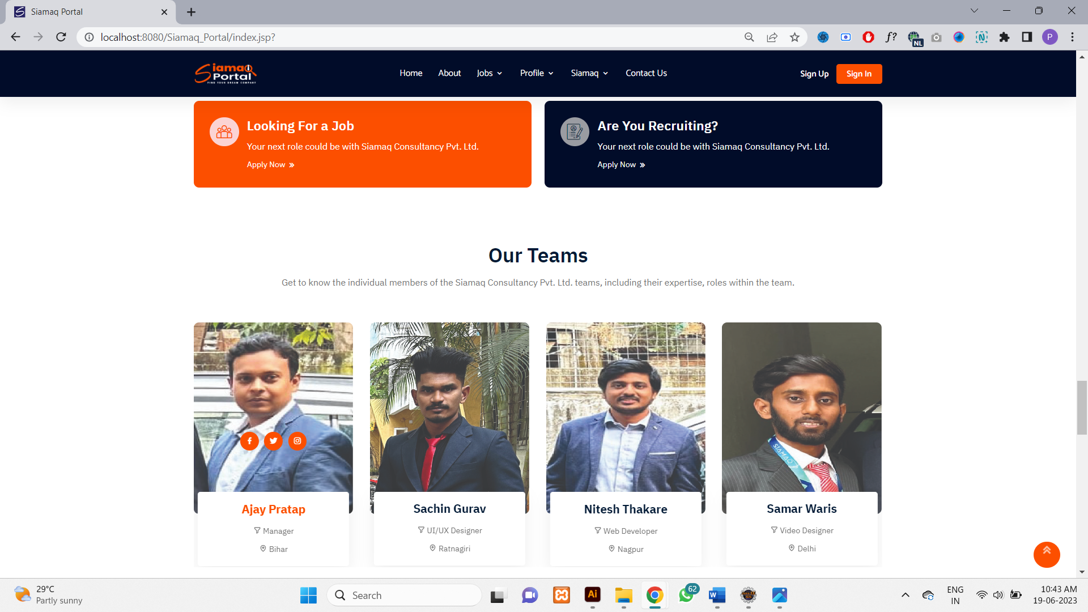

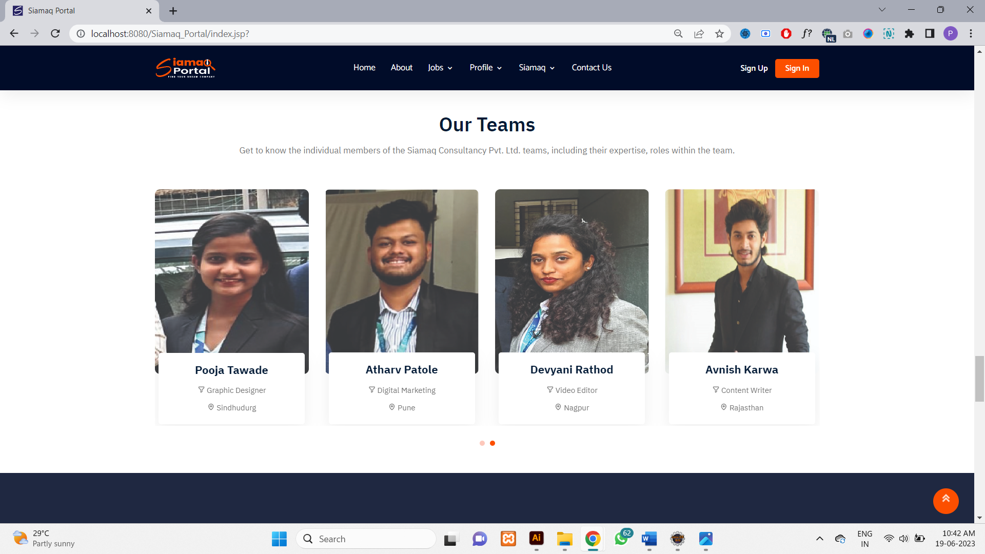

Fig 1.1 Home Page ( Our Team Section )



Fig 1.1 Home Page ( Blogs & Footer Section )

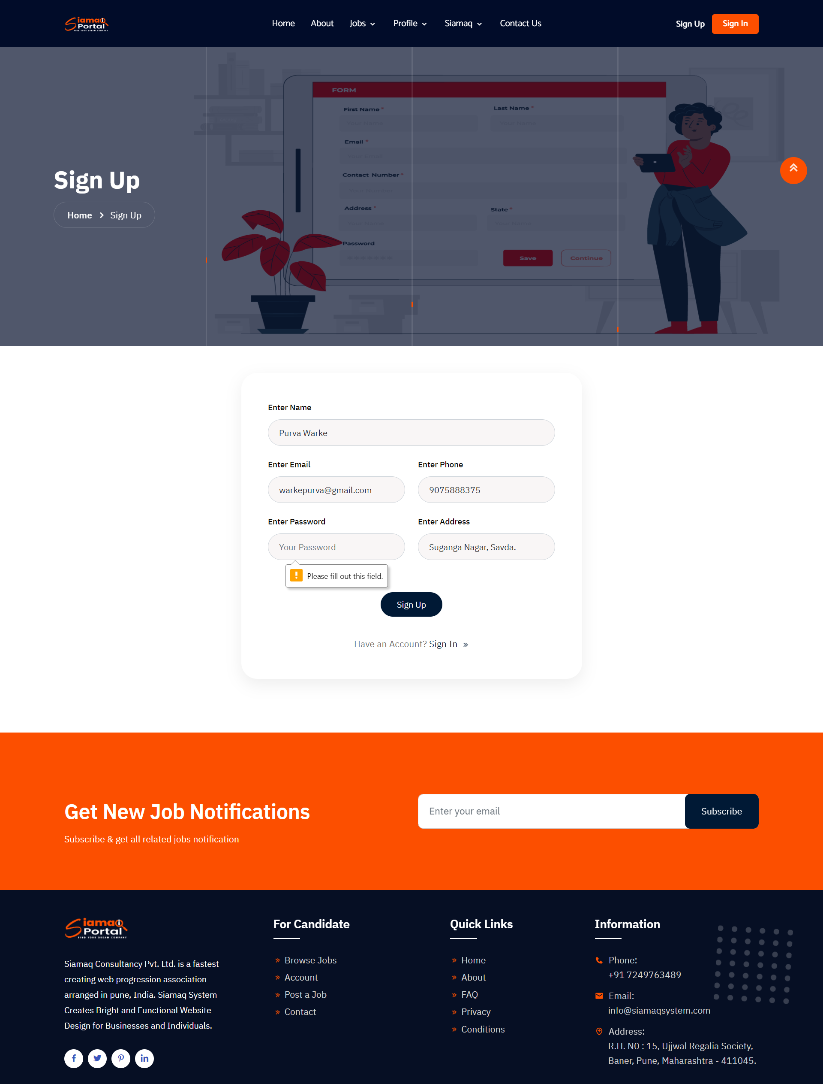

Fig 2. Sign Up Page

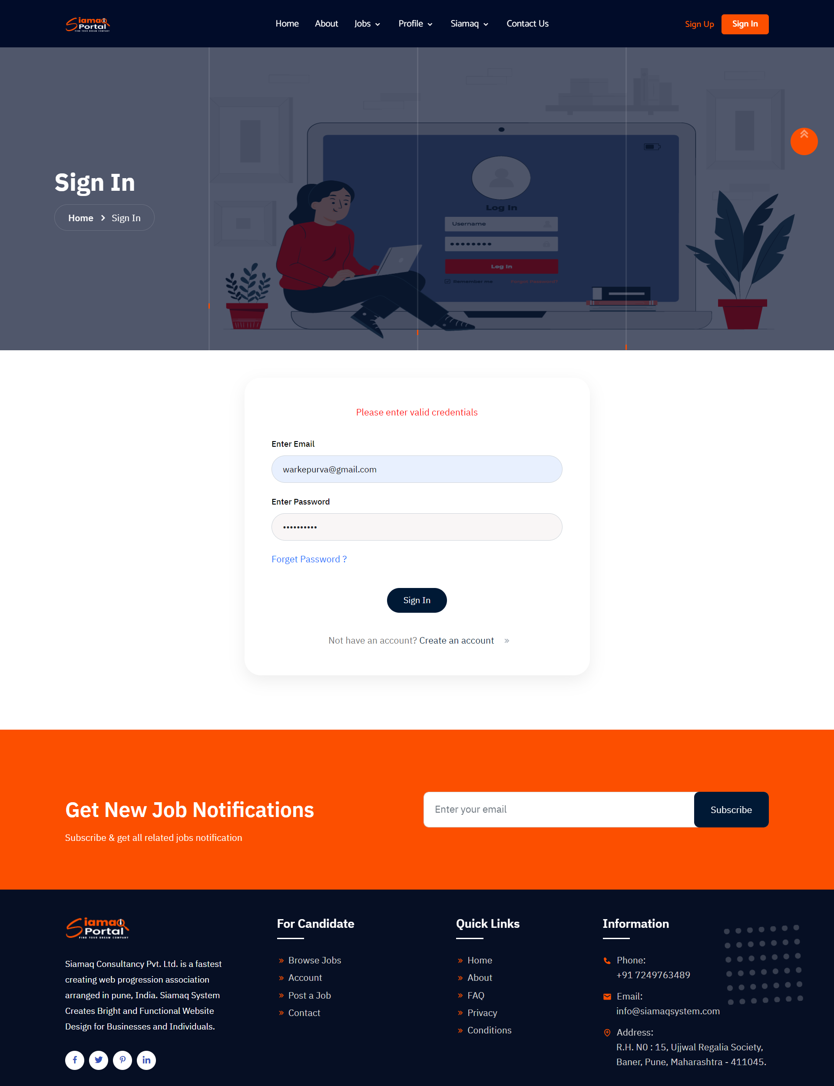

Fig 3. Sign In Page

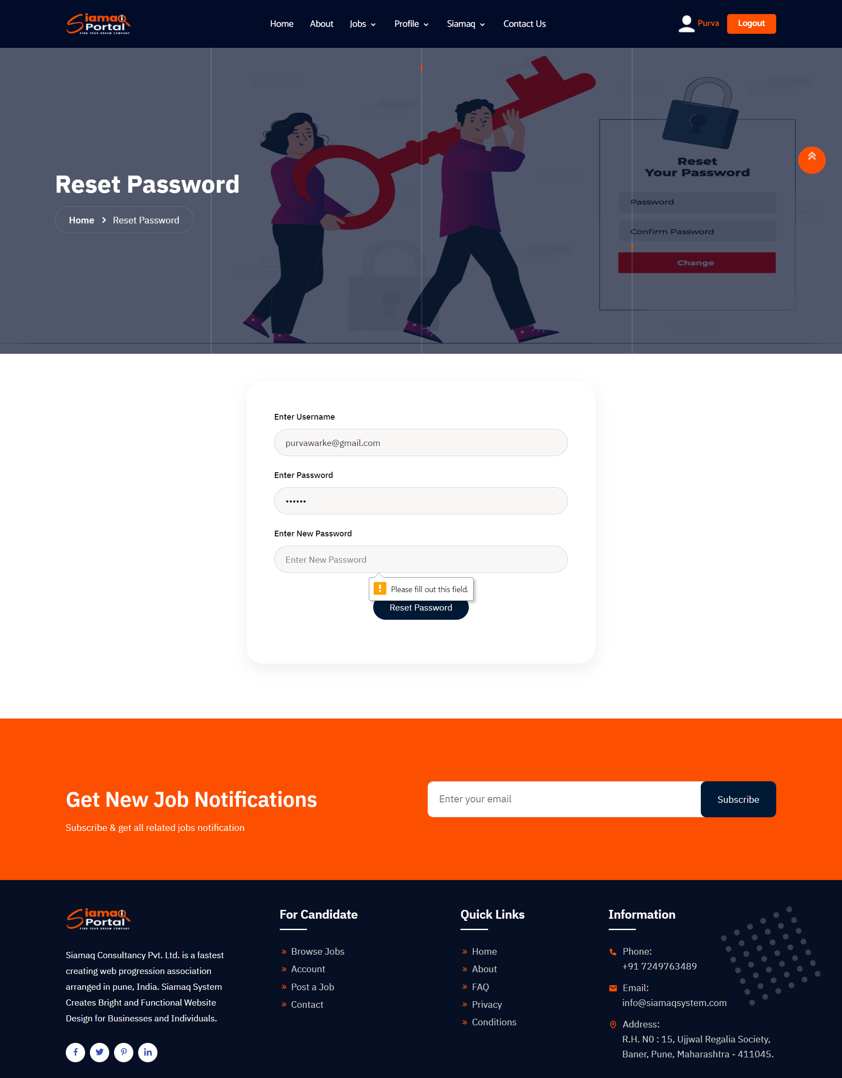

Fig 4. Sign Up Page

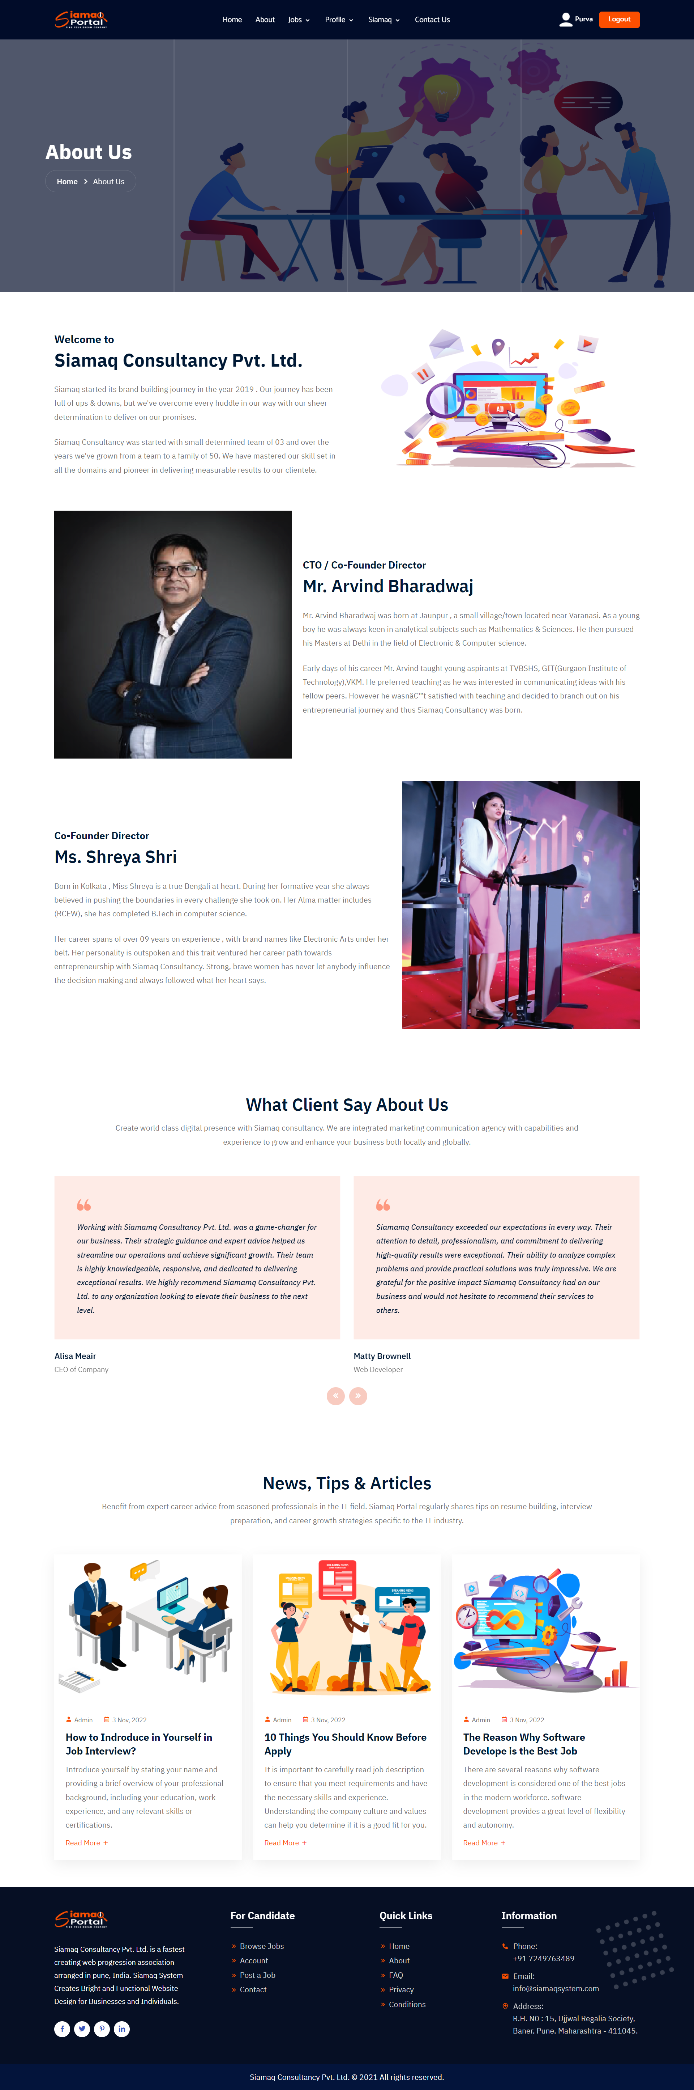

Fig 5.1 About Page ( About Section )



Fig 5.2 About Page (Testimonial Section )

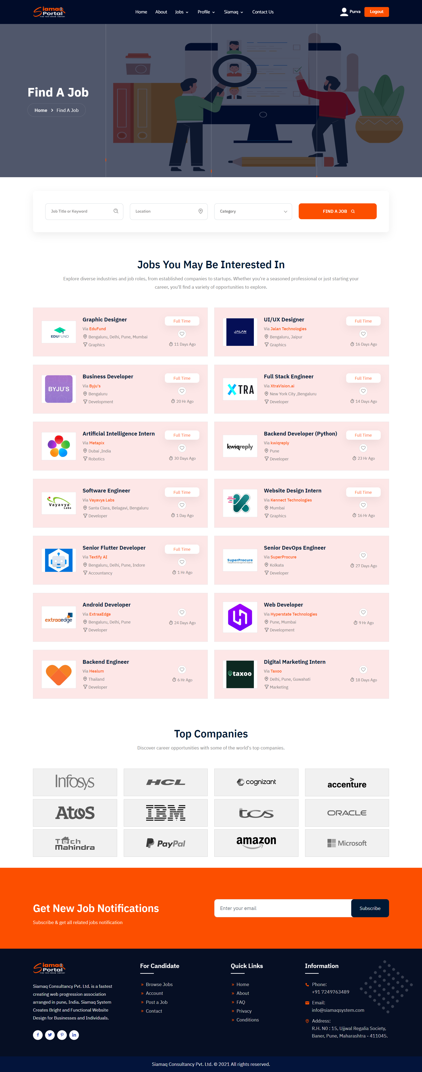

Fig 6.1 Find A Job Page ( Jobs Section )



Fig 6.2 Find A Job Page ( Top Companies Section )

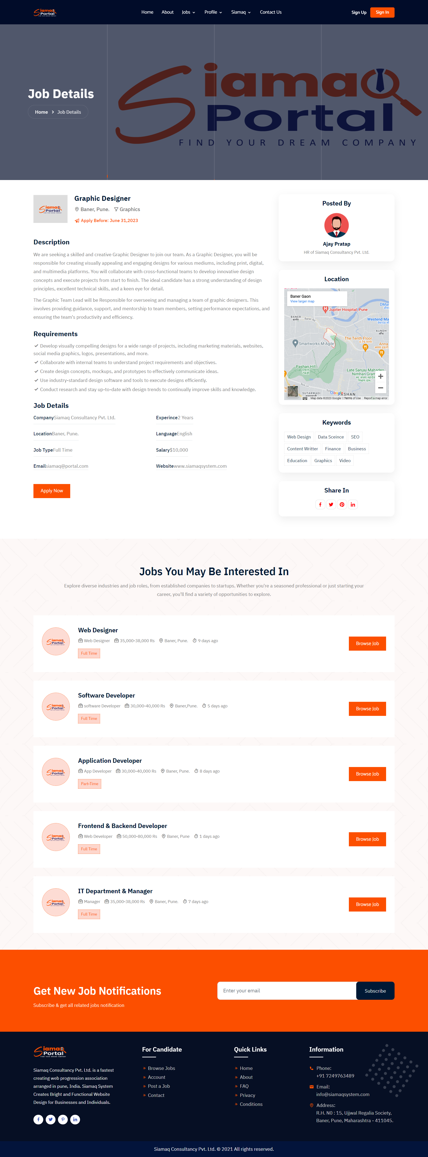

Fig 7.1 Job Details Page (job Details Section )



Fig 7.2 Job Details Page ( Another Jobs Section )

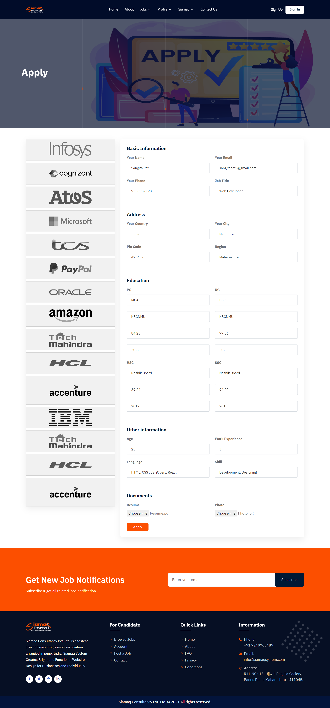

Fig 9. Job Apply Page

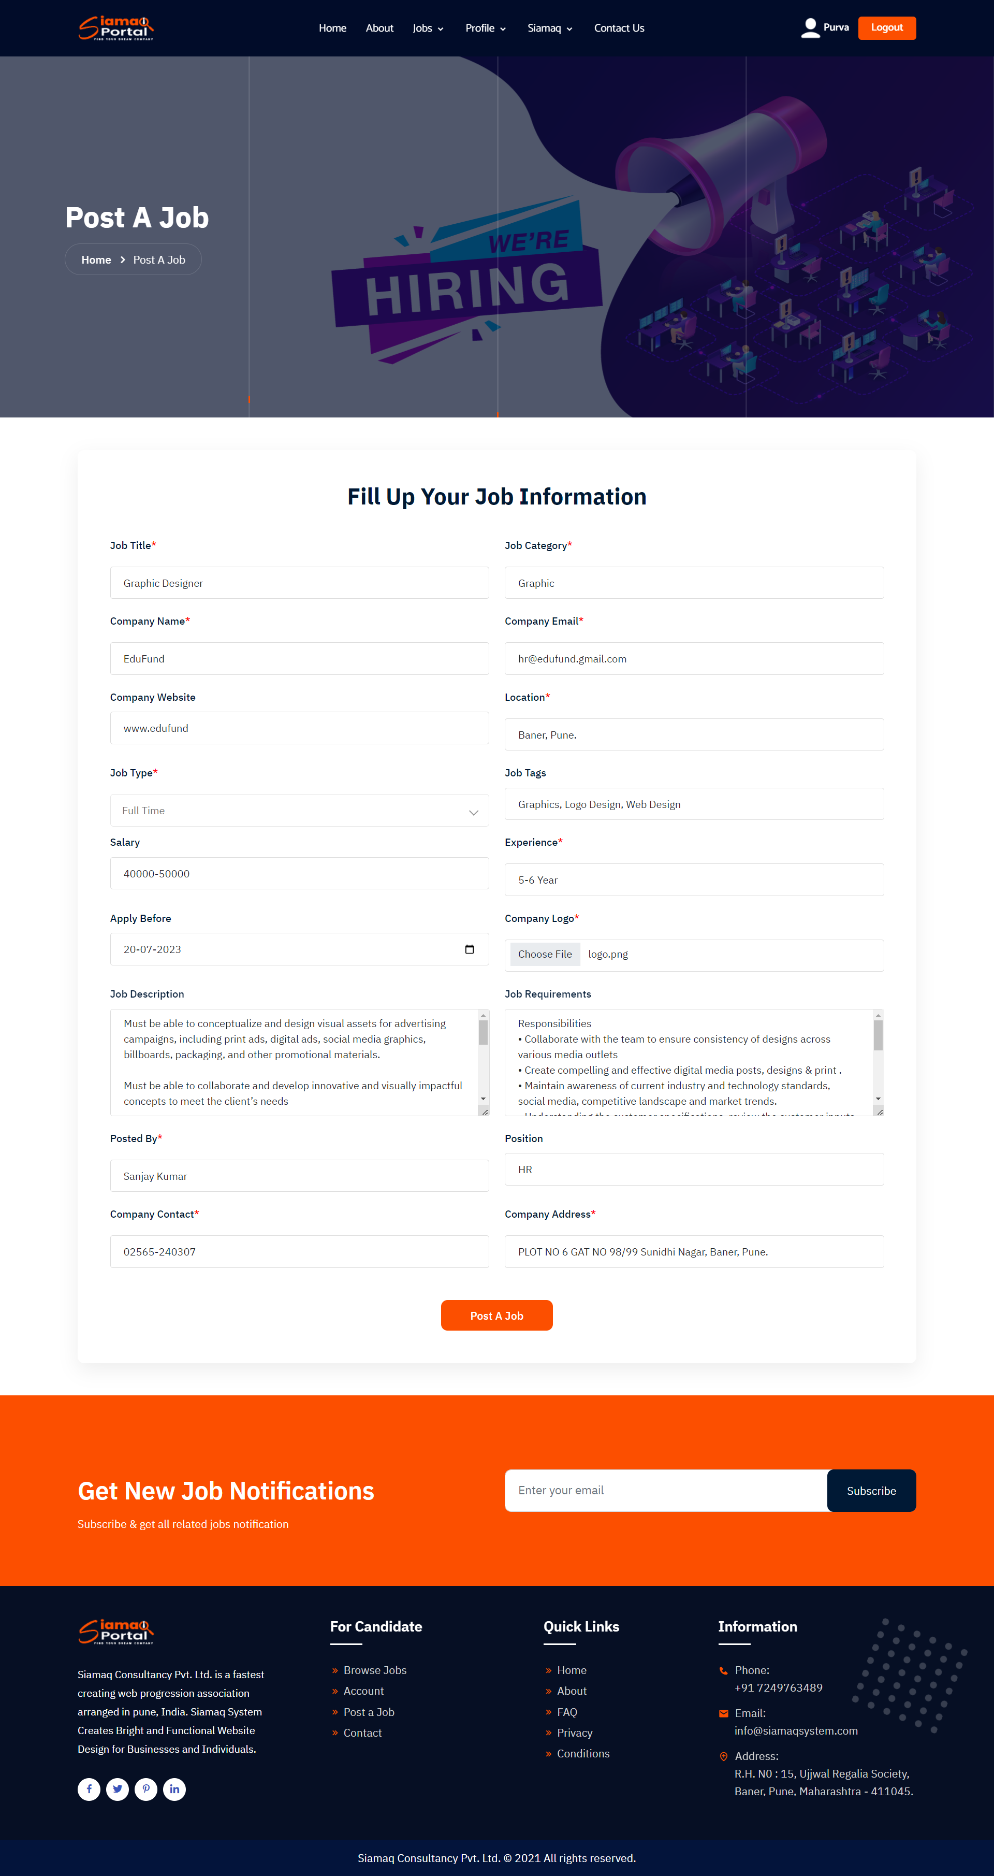

Fig 9. Job Apply Page

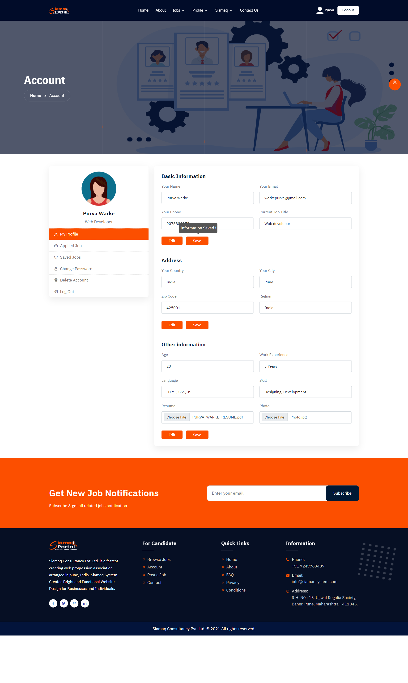

Fig 10.1 Account Page (Save Option )

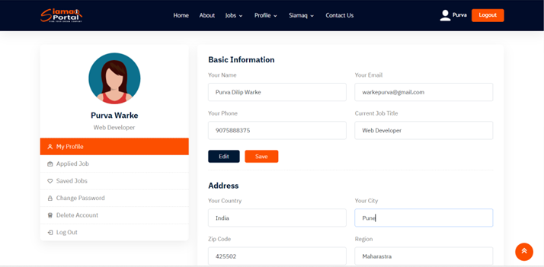

Fig 10.2 Account Page ( Edit Option )

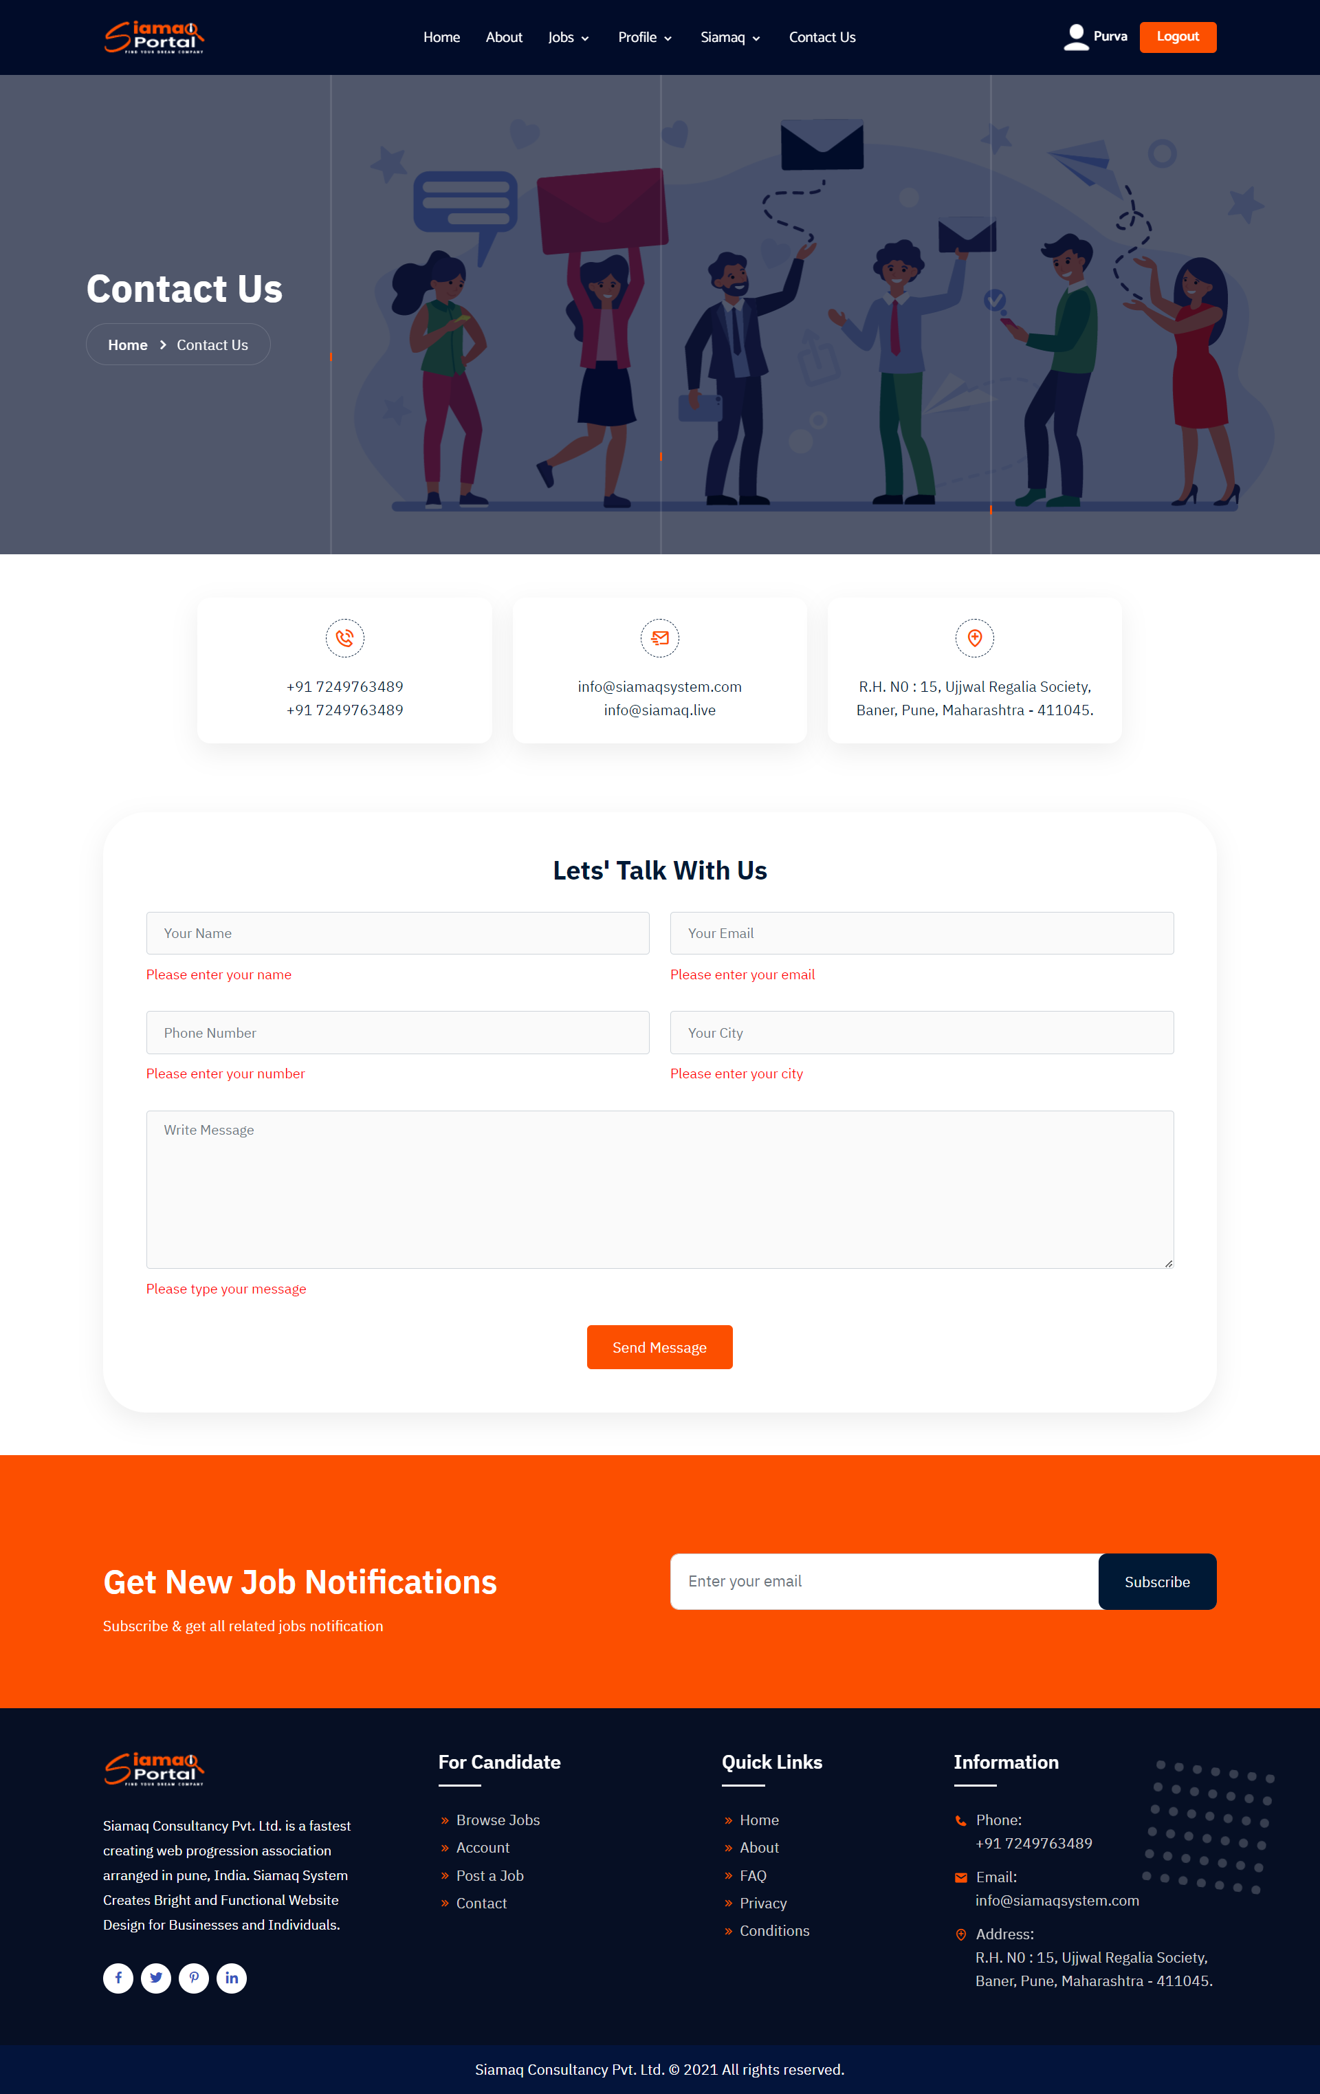

Fig 11. Contact Page

**Appendix C – List of Tables**

**Data Base Name** **:-** siamaq_db

|  |  |
| --- | --- |
| **Sr. No** | **Table Name’s** |
| 1 | siamaq.db_user |
| 2 | siamaq.db_search_bar |
| 3 | siamaq.db_subscribe |
| 4 | siamaq.db_apply_job |
| 5 | siamaq.db_post_job |
| 6 | siamaq.db_contact |
| 7 | siamaq.db_account |